How did the Egyptians build the Great Pyramids thousands of years ago (~2,500 BCE)? Could you build a pyramid using 9,000-kilogram (~10-ton or 20,000-lb) blocks of stone with your bare hands? That's like trying to move a large elephant with your bare hands! How many people might it take to move a block that big? It would still be a challenge to build a pyramid today even with modern tools, such as jackhammers, cranes, trucks and bulldozers. But without these modern tools, how did Egyptian workers cut, shape, transport and place enormous stones? Well, one key to accomplishing this amazing and difficult task was the use of simple machines.
Simple machines are devices with no, or very few, moving parts that make work easier. Many of today's complex tools are really just more complicated forms of the six simple machines. By using simple machines, ordinary people can split huge rocks, hoist large stones, and move blocks over great distances.
However, it took more than just simple machines to build the pyramids. It also took tremendous planning and a great design. Planning, designing, working as a team and using tools to create something, or to get a job done, is what engineering is all about. Engineers use their knowledge, creativity and problem-solving skills to accomplish some amazing feats to solve real-world challenges. People call on engineers to use their understanding of how things work to do seemingly impossible jobs and make everyday activities easier. It is surprising how many times engineers turn to simple machines to solve these problems.
Once we understand simple machines, you will recognize them in many common activities and everyday items. These are the six simple machines: wedge, wheel and axle, lever, inclined plane, screw, and pulley. Now that you see the pictures, do you recognize some of these simple machines? Can you see any of these simple machines around the classroom? How do they work? Well, an important vocabulary term when learning about simple machines is mechanical advantage. Mechanical advantage of simple machines means we can use less force to move an object, but we have to move it a longer distance. A good example is pushing a heavy object up a ramp. It may be easier to push the object up a ramp instead of just lifting it up to the right height, but it takes a longer distance. A ramp is an example of the simple machine called an inclined plane. We are going to learn a lot more about each of these six simple machines that are a simple solution to helping engineers, and all humans, do hard work.
Sometimes it is difficult to recognize simple machines in our lives because they look different than the examples we see at school. To make our study of simple machines easier, let's imagine that we are living in ancient Egypt and that the leader of the country has hired us as engineers to build a pyramid. Today's availability of electricity and technologically-advanced machines make it difficult for us to see what the simple machine is accomplishing. But in the context of ancient Egypt, the simple machines that we will study are the much more basic tools of the time.
Simple Machines
We use simple machines because they make work easier. The scientific definition of work is the amount of force that is applied to an object multiplied by the distance the object is moved. Thus, work consists of force and distance. Each job takes a specific amount of work to finish it, and this number does not change. Thus, the force times the distance always equals the same amount of work. This means that if you move something a smaller distance you need to exert a greater force. On the other hand, if you want to exert less force, you need to move it over a greater distance. This is the force and distance trade off, or mechanical advantage, which is common to all simple machines. With mechanical advantage, the longer a job takes, the less force you need to use throughout the job. Most of the time, we feel that a task is hard because it requires us to use a lot of force. Therefore, using the trade off between distance and force can make our task much easier to complete.
Wedge
The wedge is a simple machine that forces objects or substances apart by applying force to a large surface area on the wedge, with that force magnified to a smaller area on the wedge to do the actual work. A nail is a common wedge with a wide nail head area where the force is applied, and a small point area where the concentrated force is exerted. The force is magnified at the point, enabling the nail to pierce wood. As the nail sinks into the wood, the wedge shape at the point of the nail moves forward, and forces the wood apart.
Figure 1: An axe is an example of a wedge.
copyright

Everyday examples of wedges include an axe (see Figure 1), nail, doorstop, chisel, saw, jackhammer, zipper, bulldozer, snow plow, horse plow, zipper, airplane wing, knife, fork and bow of a boat or ship.
Wheel and Axle
The wheel and axle is a simple machine that reduces the friction involved in moving an object, making the object easier to transport. When an object is pushed, the force of friction must be overcome to start it moving. Once the object is moving, the force of friction opposes the force exerted on the object. The wheel and axle makes this easier by reducing the friction involved in moving an object. The wheel rotates around an axle (essentially a rod that goes through the wheel, letting the wheel turn), rolling over the surface and minimizing friction. Imagine trying to push a 9,000-kilogram (~10-ton) block of stone. Wouldn't it be easier to roll it along using logs placed underneath the stone?
Everyday examples of the wheel and axle include a car, bicycle, office chair, wheel barrow, shopping cart, hand truck and roller skates.
Lever
A lever simple machine consists of a load, a fulcrum and effort (or force). The load is the object that is moved or lifted. The fulcrum is the pivot point, and the effort is the force required to lift or move the load. By exerting a force on one end of the lever (the applied force), a force at the other end of the lever is created. The applied force is either increased or decreased, depending on the distance from the fulcrum (the point or support on which a lever pivots) to the load, and from the fulcrum to the effort.
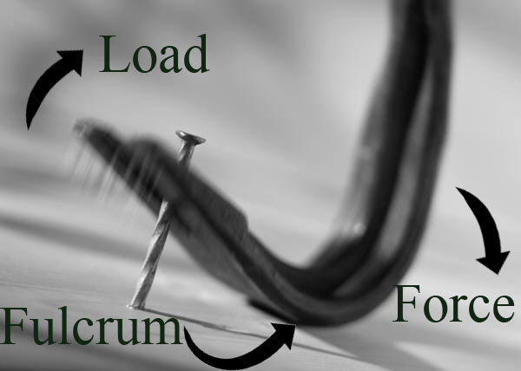Figure 2: A crowbar is an example of a lever.
copyright

Everyday examples of levers include a teeter-totter or see-saw, crane arm, crow bar, hammer (using the claw end), fishing pole and bottle opener. Think of a how you use a crowbar (see Figure 2). By pushing down on the long end of the crowbar, a force is created at the load end over a smaller distance, once again, demonstrating the tradeoff between force and distance.
Inclined Plane
Inclined planes make it easier to lift something. Think of a ramp. Engineers use ramps to easily move objects to a greater height. There are two ways to raise an object: by lifting it straight up, or by pushing it diagonally up. Lifting an object straight up moves it over the shortest distance, but you must exert a greater force. On the other hand, using an inclined plane requires a smaller force, but you must exert it over a longer distance.
Everyday examples of inclined planes include highway access ramps, sidewalk ramps, stairs, inclined conveyor belts, and switchback roads or trails.
Screw
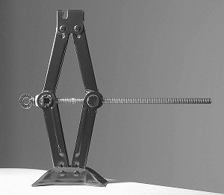Figure 3: A car jack is an example of a screw-type simple machine that enables one person to lift up the side of a car.
copyright

A screw is essentially an inclined plane wrapped around a shaft. Screws have two primary functions: they hold things together, or they lift objects. A screw is good for holding things together because of the threading around the shaft. The threads grip the surrounding material like teeth, resulting in a secure hold; the only way to remove a screw is to unwind it. A car jack is an example of a screw being used to lift something (see Figure 3).
Everyday examples of screws include a screw, bolt, clamp, jar lid, car jack, spinning stool and spiral staircase.
Pulley
Figure 4: A pulley on a ship helps people pull in a heavy fishing net.
copyright

A pulley is a simple machine used to change the direction of a force. Think of raising a flag or lifting a heavy stone. To lift a stone up into its place on a pyramid, one would have to exert a force that pulls it up. By using a pulley made from a grooved wheel and rope, one can pull down on the rope, capitalizing on the force of gravity, to lift the stone up. Even more valuable, a system of several pulleys can be used together to reduce the force needed to lift an object.
Everyday examples of pulleys in use include flag poles, elevators, sails, fishing nets (see Figure 4), clothes lines, cranes, window shades and blinds, and rock climbing gear.
Compound Machines
A compound machine is a device that combines two or more simple machines. For example, a wheelbarrow combines the use of a wheel and axle with a lever. Using the six basic simple machines, all sorts of compound machines can be made. There are many simple and compound machines in your home and classroom. Some examples of the compound machines you may find are a can opener (wedge and lever), exercise machines/cranes/tow trucks (levers and pulleys), shovel (lever and wedge), car jack (lever and screw), wheel barrow (wheel and axle and lever) and bicycle (wheel and axle and pulley).

Vocabulary/Definitions
Design: (verb) To plan out in systematic, often graphic form. To create for a particular purpose or effect. Design a building. (noun) A well thought-out plan.
Engineering: Applying scientific and mathematical principles to practical ends such as the design, manufacture and operation of efficient and economical structures, machines, processes and systems.
Force: A push or pull on an object.
Inclined plane: A simple machine that raises an object to greater height. Usually a straight slanted surface and no moving parts, such as a ramp, sloping road or stairs.
Lever: A simple machine that increases or decreases the force to lift something. Usually a bar pivoted on a fixed point (fulcrum) to which force is applied to do work.
Mechanical advantage : An advantage gained by using simple machines to accomplish work with less effort. Making the task easier (which means it requires less force), but may require more time or room to work (more distance, rope, etc.). For example, applying a smaller force over a longer distance to achieve the same effect as applying a large force over a small distance. The ratio of the output force exerted by a machine to the input force applied to it.
Pulley: A simple machine that changes the direction of a force, often to lift a load. Usually consists of a grooved wheel in which a pulled rope or chain runs.
Pyramid: A massive structure of ancient Egypt and Mesoamerica used for a crypt or tomb. The typical shape is a square or rectangular base at the ground with sides (faces) in the form of four triangles that meet in a point at the top. Mesoamerican temples have stepped sides and a flat top surmounted by chambers.
Screw: A simple machine that lifts or holds materials together. Often a cylindrical rod incised with a spiral thread.
Simple machine: A machine with few or no moving parts that is used to make work easier (provides a mechanical advantage). For example, a wedge, wheel and axle, lever, inclined plane, screw, or pulley.
Spiral: A curve that winds around a fixed center point (or axis) at a continuously increasing or decreasing distance from that point.
Tool: A device used to do work.
Wedge: A simple machine that forces materials apart. Used for splitting, tightening, securing or levering. It is thick at one end and tapered to a thin edge at the other.
Wheel and axle: A simple machine that reduces the friction of moving by rolling. A wheel is a disk designed to turn around an axle passed through the center of the wheel. An axle is a supporting cylinder on which a wheel or a set of wheels revolves.
Work: Force on an object multiplied by the distance it moves. W = F x d (force multiplied by distance

