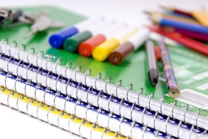 4th Grade Supply List
*Book bag
*Pencil box
*Highlighter-2
*Colored pencils
*Pencils-4
*One subject spiral notebook with a black cover-1
*2 pocket folder for homework-1
*Glue sticks-1 large or 2 small
*Kids scissors
*A box of Kleenex for classroom use
*One bottle of hand sanitizer for classroom use

**Please do not send trapper keepers or 3 ring binders because they do not fit in the desks.**

