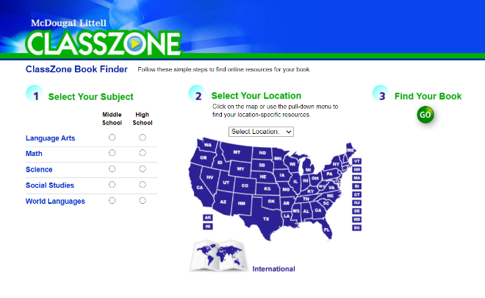
- The textbook we use for Spanish 1 is called Avancemos 1. To find it online, first go to www.classzone.com. It will look like this:

- In each space, fill in the correct information – 1) Choose World Languages and High School; 2) choose PA; 3) click GO

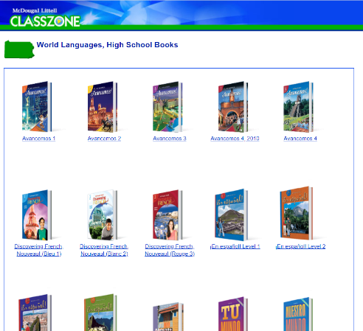
- The next page will look like this:
Our book is Avancemos 1, so just click
on it!

- The next page will look like this:
We will use the 2007 Online Book (bottom left corner), so just click on it
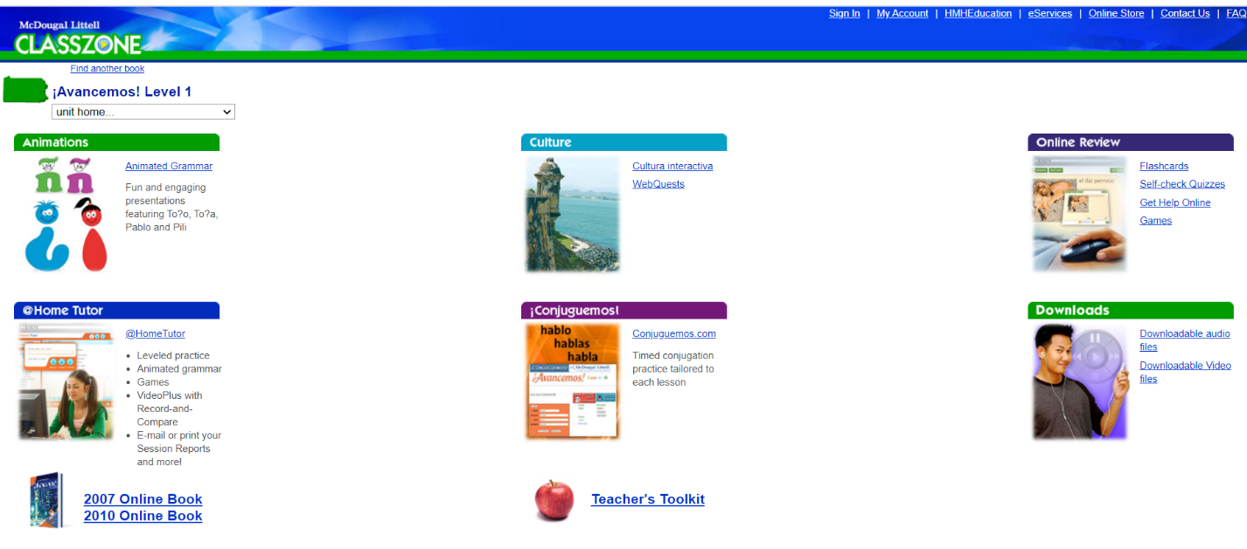

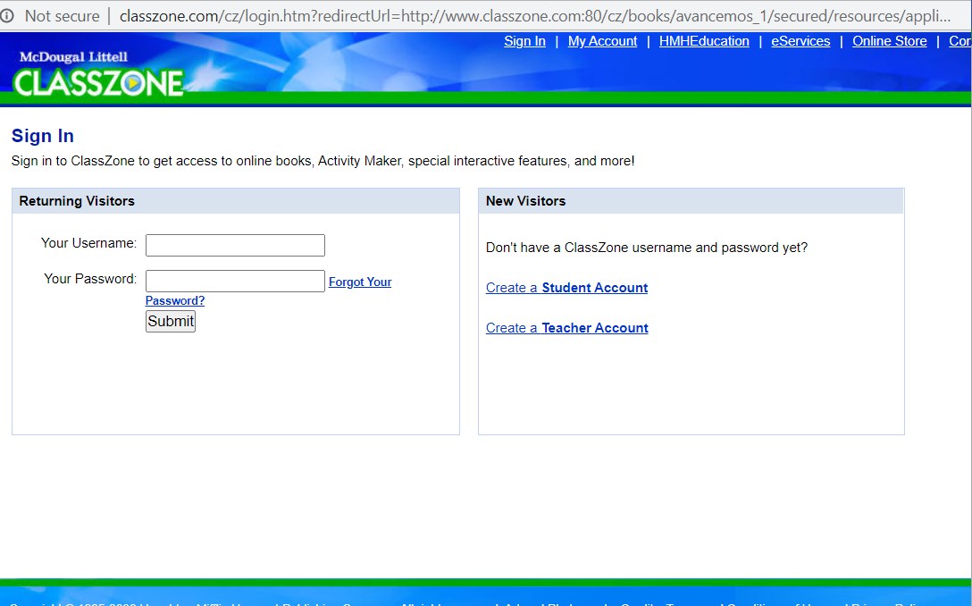
- The next page looks like this:
Click on Create Student Account

- The next page asks for an activation code. The code for Spanish 1 is 2629614-10. Enter the numbers (the 10 at the end goes in the second box after the dash) and click continue. The next page will ask for your birth date – enter that and the next page will look like this:
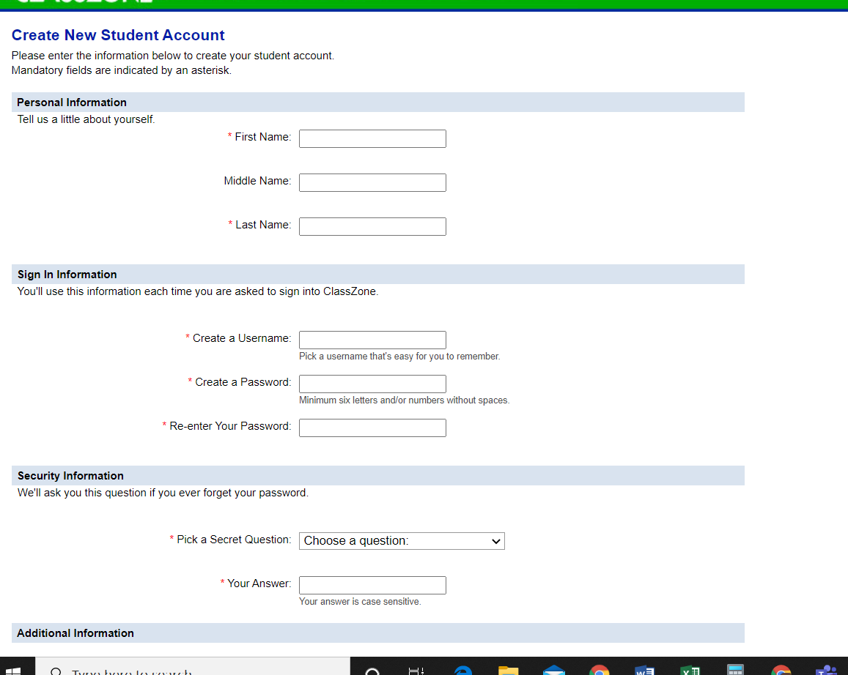

- Fill in the information – make sure you keep track of your user name and password, because you’ll need to get back into this site for the book every day this year!

- After it tells you the registration is complete, click Go to Classzone! And you will see this page:

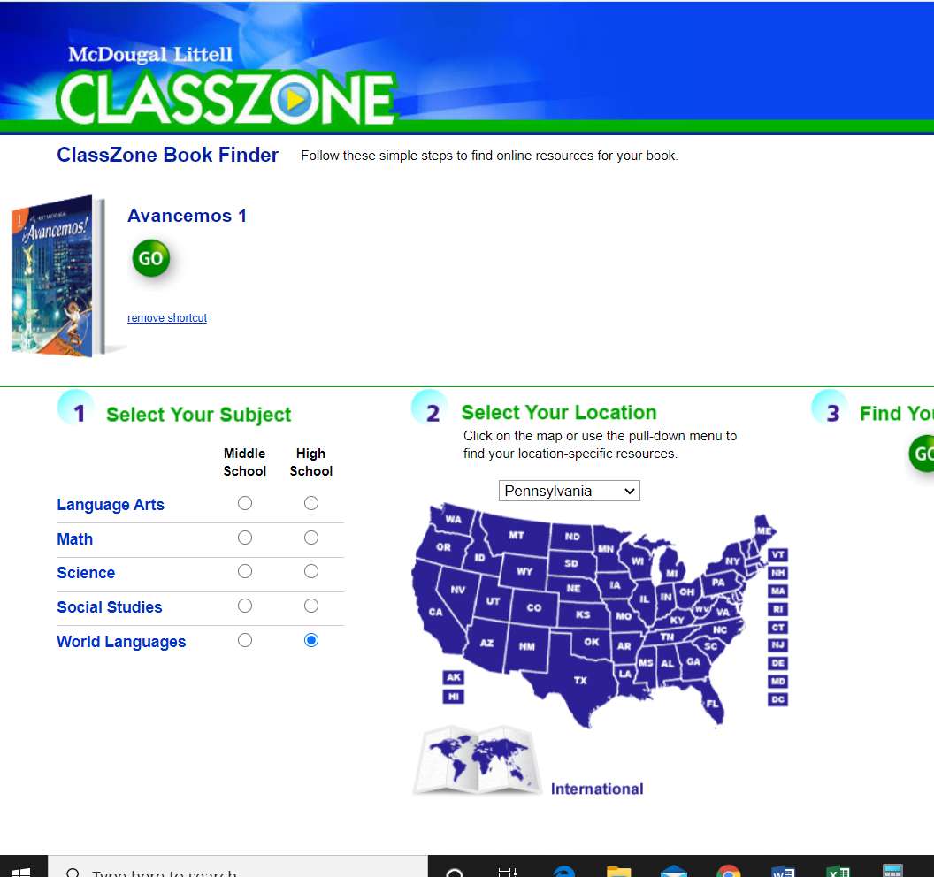

Click on the green GO, then click on 2007 Online Book again at the bottom. You may have to allow Flash Player to work, but then the book will open and you will see this:
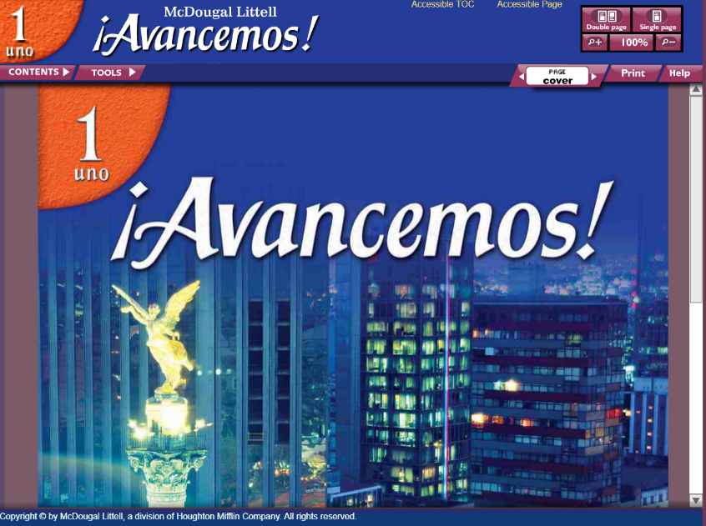

Use the tools at the top to see how to navigate through the book until everyone is ready!

