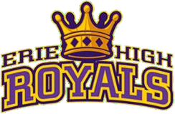

Course Materials:

COURSE OUTLINE: Wellness/Fitness
Mr. King mking@eriesd.org
814-874-6200

- Five For Life Curriculum
- FLASH Curriculum
- LMS – Schoology

Description:
Focus on the Four Pillars of Self Care: Physical Literacy, Health Literacy, Nutrition, and Social Emotional Learning (SEL) through a series of stations each day may include:

- Complete Daily Do Now’s for reflective class starters
- Complete Daily Word Wall Ticket for wellness vocabulary
- Complete Daily Content Assignment – completion of daily health emergency content assignment
- Assessments
- May assign projects or have other assessments as needed

Classroom Organization may include:
- Attendance
- Review agenda for the day on the virtual white board
- Complete the Do Now
- Fitness
- Discuss Daily Word Wall
- Complete the Word Wall
- Daily Activity
- Direct instruction on daily content
- Closing Thoughts

