Newcomer Math EL
Mrs. Maynard
jmaynard@eriesd.org

Welcome! I am looking forward to a great year teaching you mathematical concepts while also practicing our literacy skills (reading, writing, speaking, listening, and thinking). In this class, you will be expected to show up, participate, reflect, communicate, and learn through whole group, partner, and individual work.
Tests/Quizzes: Tests and quizzes are given often and make up the majority of the grade for this class. Retests will be given following the requirements of the District policy.
Homework: Homework assignments will provide students with an opportunity to practice what they’re learning in the classroom. It is a tool in the learning process, not an instrument to measure understanding.
Class Work: Class work will be given daily, and will be graded on completion. During class is when it is a good idea to ask questions if you do not understand a concept. I care about you, and I want you to succeed! Therefore, class work is there as practice, and you should leave this room learning something new every day!
Routine: Every day, you will come into the class and grab your folder, notebook, and text book. You will then answer the Do Now question. After 5 or so minutes, Mrs. Maynard will greet everyone, and we will get started with class. PLEASE MAKE SURE TO COME PREPARED WITH A PENCIL EVERY DAY!!!
What we will learn:
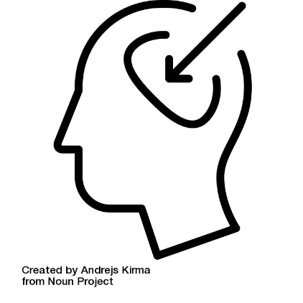
Module 1- Numbers and Operations
Module 2- Algebraic Concepts
Module 3- Geometry
Module 4- Measurement, Data, and Probability
Module 5- Financial Literacy
Module 6- Algebraic Concepts part 2
Grading:
Tests & Quizzes…………….…….…………. 60%
Class Work/Participation……….………. 30% Parent Name: __________________________________________ Homework…………………………………….. 10% Parent Signature: _______________________________
*Parents: please feel free to email me any time you have a question or concern: jmaynard@eriesd.org

District Grading Scale:
A: 90-100 B: 80-89 C: 70-79 D: 65-69 F: 0-64

Extra Help:
Tuesday. Extra Help is another tool for you to practice what you have learned in class. You may also use this time to make up tests and quizzes that you may have missed.
Online Learning:
Make sure that your Chrome book is charged and ready to go every day. We will utilize it at least once a day in school, and you will be expected to complete online assignments.

