Name: ______________________________________ Date: ________________________

Student Exploration: Disease Spread

Vocabulary: disease, epidemic, infect, infectious disease, pathogen

Prior Knowledge Questions (Do these BEFORE using the Gizmo.)

- Why do you think it is important to cover your mouth when you cough? _________________

_________________________________________________________________________

_________________________________________________________________________

- Why should you always wash your hands before you eat? __________________________

_________________________________________________________________________

_________________________________________________________________________

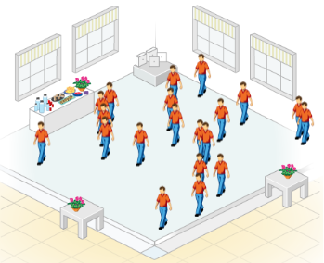
Gizmo Warm-up
When a person has a disease, his or her normal body functions are disrupted. Some diseases, such as diabetes and most cancers, are not spread from one person to another. But other diseases, such as the flu and strep throat, can be spread. These diseases are known as infectious diseases. Infectious diseases are caused by viruses, bacteria, and other agents known as pathogens.

In the Disease Spread Gizmo, you will be able to observe how various pathogens can spread through a group of people. Click Play () and observe.

- Describe what happened on the SIMULATION pane: _______________________________

_________________________________________________________________________

_________________________________________________________________________

- Look at the color key on the bottom right of the Gizmo. What is happening when a person changes color? ____________________________________________________________
_________________________________________________________________________

Activity A:  Person-to-person transmission | Get the Gizmo ready:  - Click Reset ().  - On the CONTROLS tab under Active Diseases, turn off Foodborne and turn on Person to person.  - Set the Number of people to 5. | 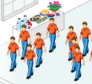

Question: What factors affect how quickly a pathogen spreads from person to person?

- Predict: Some pathogens are spread directly from one person to another. This can happen when people come into direct contact or share items, such as drinking glasses. What do you think might affect how quickly a pathogen is spread from person to person?

_________________________________________________________________________

_________________________________________________________________________

- Identify: Select the SIMULATION tab on the left and the TABLE tab on the right. (You will want the table tab open to answer question C.)

    - What does the purple person represent? __________________________________

    - Click Play, and observe the simulation for a while. What must happen for the disease to spread from one person to another? ____________________________________
    - How long did it take to infect five people? _________________________________

- Experiment: Click Reset. Change the Number of people to 15. Click Play, and record how long it takes to infect five people. Then repeat the experiment when there are 25 people and 35 people in the room.

Number of people in room | Time required to infect five people (hr)
15
25
35

- Interpret: Study the data you collected. What trend do you see in the data, and how would you explain it? _____________________________________________________________
_________________________________________________________________________

_________________________________________________________________________

(Activity A continued on next page)
Activity A (continued from previous page)

- Experiment: Not all pathogens are equally infectious. Click Reset. Set the Number of people to 20. Under Probability of transmission, select Low for Person to person.

On the SIMULATION tab, click Play. Record the time it takes to infect five people. Then repeat the experiment with a medium and high probability of transmission. (Note: For the “Medium” setting, move the slider half-way between the Low and High positions.)

Probability of Transmission | Time required to infect five people (hr)
Low
Medium
High

- Interpret: Study the data you collected in the table above. What trend do you see in the data, and how would you explain it? _________________________________________________
_________________________________________________________________________

_________________________________________________________________________

- Analyze: On the CONTROLS tab, place the Probability of transmission slider under Person to person half-way between Low and High. Select the SIMULATION and GRAPH tabs. Click Play.

    - At what time did the disease spread most slowly? Most quickly? ________________

___________________________________________________________________

    - How could you explain this change in the rate of the disease’s spread? __________

___________________________________________________________________

___________________________________________________________________

___________________________________________________________________

___________________________________________________________________

- Apply: An epidemic is the rapid spread of an infectious disease. How do you think a government could try to prevent an epidemic of a dangerous person-to-person pathogen?

_________________________________________________________________________

_________________________________________________________________________

