To my WONDERFUL students,

I miss you all, and hope that you and your families are doing
well at this time! This is an interesting time to be alive!

During this time away from the classroom, I urge you to continue to practice your instruments and to make music! We have come SO far this year, and would love to continue our progress. I am so proud of all of you for what you have been able to accomplish…Keep it up! Music is a form of expression and communication, and since we are all practicing social distancing, use this time to create and express your emotions through MUSIC.

On my home page, I posted a few things that I would like to go over in this letter.

If you are interested in having 1:1 (or even small group) lessons, e-mail me so that we can set up a time! It would be like a little virtual band class! (or guitar class!)

If you have not done so already, please sign up for our SV BAND remind group by texting “@SVban” to 81010. This will keep you updated with important things.

I have created a bingo board called BANDO. This is a fun way to practice…those who finish their boards by the time we come back may have a prize!! (Who knows!!)

I have also posted some composer articles/questions for those of you who may have forgotten your instrument (or don’t have one).

Remember, these are for enrichment purposes only, but I highly recommend keeping up your chops for your instrument so that we can jump right back into our successful rehearsals when we come back!

Don’t forget, I am available if you need something, so please do not hesitate to send me an e-mail!
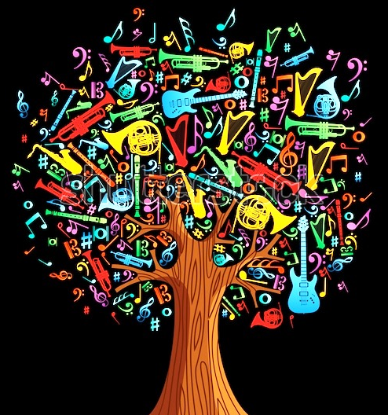
Musically yours,
Ms. Grondziowski

