GOOGLE CLASSROOM INSTRUCTIONS
Here are the steps to follow to see your child’s Google Classroom Dashboard. As always, please continue to email or Dojo your child’s teacher with any questions:

- Go to https://classroom.google.com/
- Login using your child’s email address (districtIDnumber@eriesd.org) and unique password.

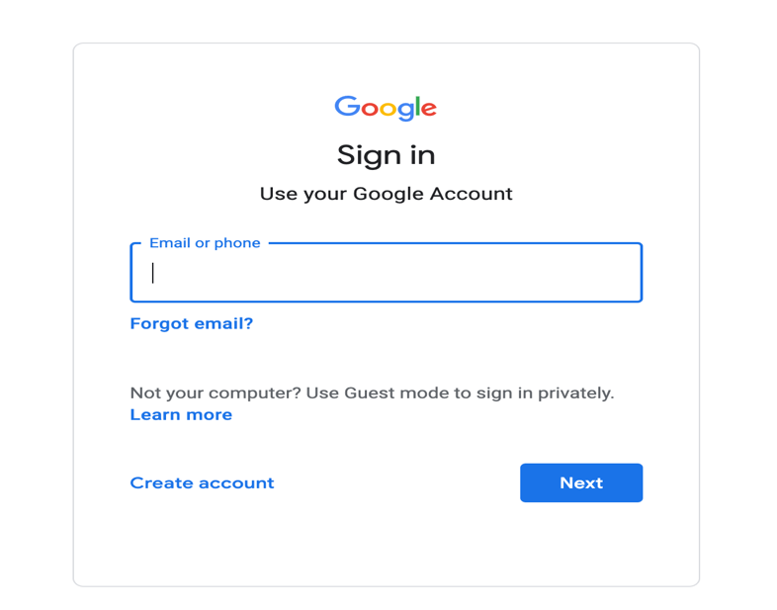

- Once you have logged in, you will see your child’s dashboard.

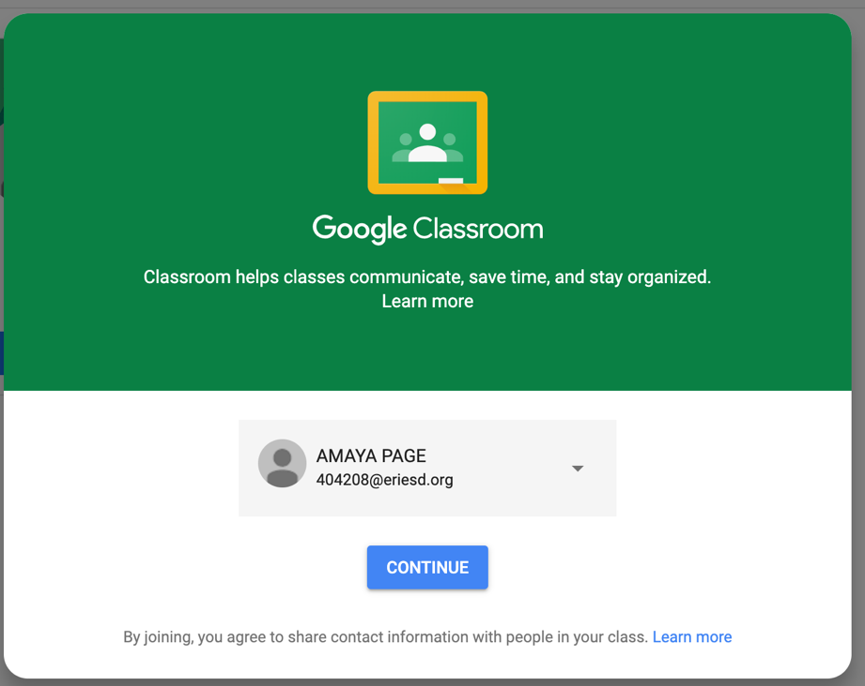

- Click student

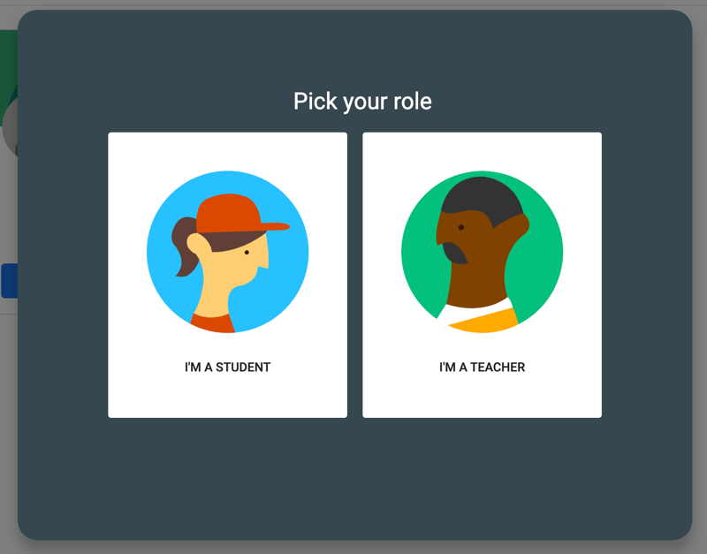

- Once on the dashboard, click on any class to view its Google Classroom page.

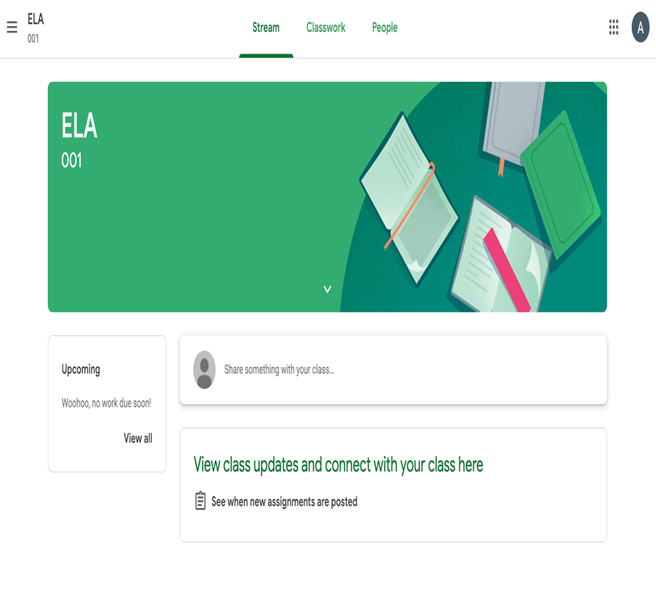

- Click on the little three line icon in the upper left hand corner to view the course menu.

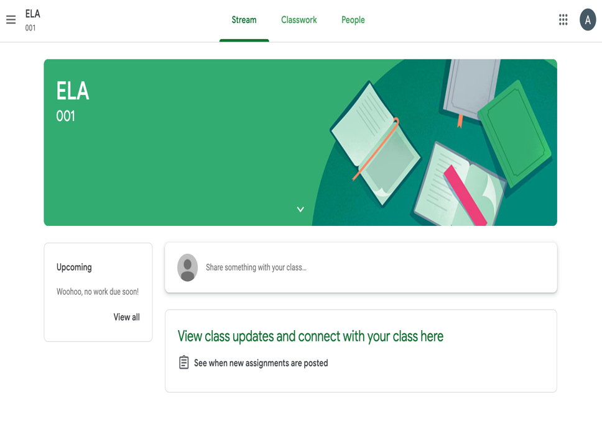

- If you have more than one child using Google Classroom, you can add both accounts and view both students from the same site. To add another account, click on the email address you see in the upper right corner of the dashboard, and select “Add account.”

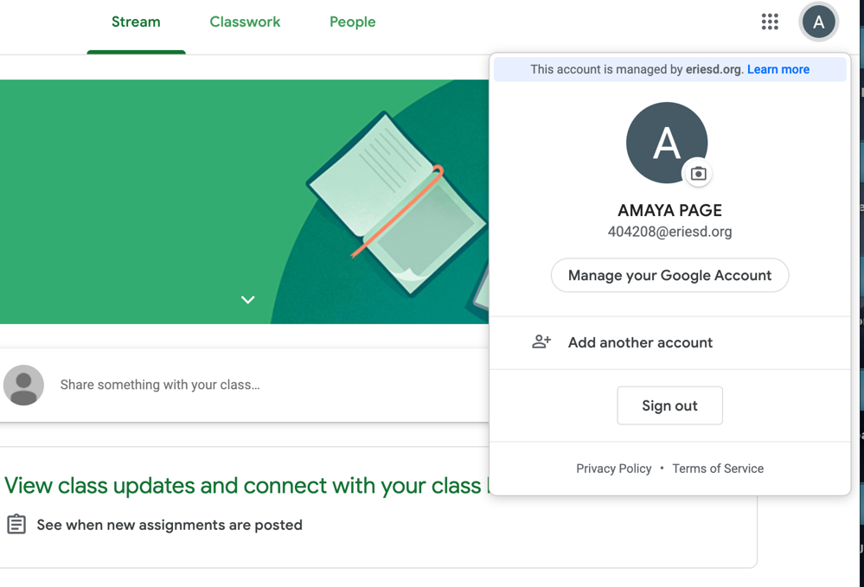
- To switch between accounts, click on the email address in the upper right corner of the dashboard, and just select the account you would like to see.

