Pre-Engineering

**Mr. Beiter – Room 170**

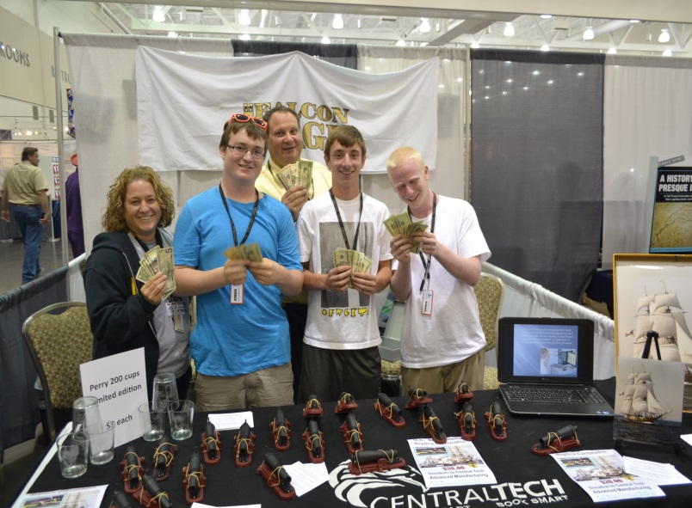

**COURSE OBJECTIVES**

1. Students will develop an understanding of the core concepts of technology and design.
2. Students will use engineering concepts of design and problem-solving skills to develop products for manufacturing.
3. Students will be able to write technical documents and build communication with professional personnel.
4. Students will build desired skills in preparation for college and careers post graduation.

# TOPICS

|  |  |
| --- | --- |
| 1st & 2nd Year | 3rd & 4th Year |
| Engineering Safety | Engineering Safety |
| Computer Aided Drawing | Computer Aided Drawing |
| Fields of Engineering | Engineering Systems |
| Design Process | Materials & Manufacturing Processes |
| Electrical Systems | Electrical Systems |
| Materials & Manufacturing Processes | Structural Systems |
| Hydraulics & Pneumatics | Robotic Systems |

## CAREER READINESS, SAFETY & INDUSTRY CERTIFICATIONS

* Career Readiness Program – resumes, interview skills, cover letter, and portfolios.
* OSHA 10 Certification (Occupational Safety & Health Administration)
  + General Industry safety (MSDS, Slip and Fall, PPE, Blood Borne Pathogens)
* Tooling U-SME delivers versatile, competency-based learning and development solutions to the manufacturing community. classes are accessible 24/7
* FANUC CERT Robotic Certification learn to utilize the latest automation technology in robots, CNC, ROBODRILL, and integrated solutions while applying science, technology, engineering, and math (STEM) skills.

## CLASSROOM EXPECTATIONS

Students are expected to:

* Be prepared (textbook, pen/pencil, flash drive, completed assignments, and calculator, 3-ring binder).
* Complete class assignments and homework, maintain a notebook and prepare for assessments.
* Be on time for class and participate in class discussions and projects.
* Complete work missed during an absence.
* Follow school and district policies.
* Attend extra help when class material needs additional explanation.

## MATERIALS

1. Pen/pencil
2. 1 GB Flash Drive
3. TI-30XIIS Calculator (Texas Instruments)
4. 3-Ring Binder w/ sheet protectors

## ABSENCES

* Students are responsible for all work missed during an absence (this includes notes). Work missed due to an unexcused absence will receive a “0”. (Refer to the discipline policy.)

## GRADING

* Quarter grades will be comprised of tests, class assignments, class notes, homework, projects, career & safety portfolio, Do Nows/bell ringers, and quizzes.
* Quarter grades will be determined by dividing the number of points earned by the number of points possible.
* The final grade is computed by averaging the percentages earned for each of the four quarters. (Note: An actual earned grade will be reflected on the report card.)

### ERIE SCHOOL DISTRICT GRADING SCALE

**A 90% - 100%**

**B 80% - 89%**

**C 70% - 79%**

**D 65% - 69%**

**F 0% - 64%**

**TESTS**

* Tests are announced at least **two** classes in advance.

# CLASS ASSIGNMENTS

* Class assignments are to be completed in class. Any assignment not completed in class will receive a “0”.Absent students must be “excused” to make up the missed work.
* Class assignments should include student’s name, date, and assignment.

# PROJECTS

* All Projects will need to be completed by a desired deadline.
* Projects will be graded depending on the overall completeness and efforts towards the finished product.
* Any project unfinished by the deadline will result in a zero.

**MANUFACTURING**

* Students are responsible to acquire training on the various manufacturing equipment (CNC Router, Laser Engraver, 3D Printer) in the lab.
* Students will participate in engineering design reviews that will encompass the process as which a finished product will be manufactured.

# DO NOWS/BELL-RINGERS

* Do Nows are given at the beginning of each period and shall be completed in the provided composition notebook. Notebooks will be graded every two weeks and are awarded 2 points per Do Now (20 points total every two weeks)
* Do Nows must include the problem, date, circled answer, and all work must be shown to receive full credit.
* Students that have an excused absence are exempt from that missed Do Now.

# EXTRA HELP

* Extra help is available every morning and Monday afternoon. Additional times can be scheduled if necessary.

Classroom rules

1. When I am talking you are not.
2. You are to stay in seats unless directed otherwise.
3. Students will respect others in class both physically and verbally
4. During class time your attention is expected
5. Food and drink are a privilege based on behavior.
6. All rules delineated in the 2019-2020 EHS discipline Handbook are in effect in this Room

# LAB / SAFETY Rules

1. No Horseplay, Running or wrestling in the lab
2. Must complete Safety test prior to using any piece of equipment
3. Immediately report any malfunctioning equipment ( i.e. Feels hot, Smoke, odor etc.)
4. Use of Appropriate PPE ie. safety glasses are required
5. use of Engineering equipment is only for authorized projects (only Mr. Beiter or Mrs. McCorkle authorize)
6. All rules delineated in the 2019-2020 discipline Handbook are in effect in this lab