Transcendentalism is a very formal word that describes a very simple idea. People, men and women equally, have knowledge about themselves and the world around them that "transcends" or goes beyond what they can see, hear, taste, touch or feel.
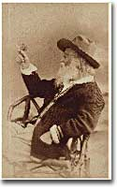
This knowledge comes through intuition and imagination not through logic or the senses. People can trust themselves to be their own authority on what is right. A transcendentalist is a person who accepts these ideas not as religious beliefs but as a way of understanding life relationships.
The individuals most closely associated with this new way of thinking were connected loosely through a group known as The Transcendental Club, which met in the Boston home of George Ripley. Their chief publication was a periodical called "The Dial," edited by Margaret Fuller, a political radical and feminist whose book "Women of the Nineteenth Century" was among the most famous of its time. The club had many extraordinary thinkers, but accorded the leadership position to Ralph Waldo Emerson.
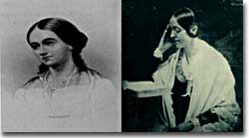
Emerson was a Harvard-educated essayist and lecturer and is recognized as our first truly "American" thinker. In his most famous essay, "The American Scholar," he urged Americans to stop looking to Europe for inspiration and imitation and be themselves. He believed that people were naturally good and that everyone's potential was limitless. He inspired his colleagues to look into themselves, into nature, into art, and through work for answers to life's most perplexing questions. His intellectual contributions to the philosophy of transcendentalism inspired a uniquely American idealism and spirit of reform.
Walt Whitman’s Leaves of Grass introduced the “free verse” style of poetry, reflecting the individualistic tone of transcendentalism. This picture of Whitman with a butterfly appeared in the 1889 edition.
The theory of books is noble. The scholar of the first age received into him the world around; brooded thereon; gave it the new arrangement of his own mind, and uttered it again.
It came into him again, life; it went out from him, truth.
It came to him, short-lived actions; it went out from him, immortal thoughts.
Margaret Fuller played a large part in both the women’s and Transcendentalist movements. She helped the community at Brook Farm, as well as Editing The Dial, and writing the feminist treatise, Women in the Nineteenth Century.
It came to him, business; it went from him, poetry.
It was dead fact; now, it is quick thought.
It can stand, and it can go.
It now endures, it now flies, it now inspires.
Precisely in proportion to the depth of mind from
which it issued, so high does it soar, so long does it sing.
-Excerpt from The American Scholar, Ralph Waldo Emerson
The Transcendental Club was associated with colorful members between 1836 and 1860. Among these were literary figures Nathaniel Hawthorne, Henry Wadsworth Longfellow, and Walt Whitman. But the most interesting character by far was Henry David Thoreau, who tried to put transcendentalism into practice. A great admirer of Emerson, Thoreau nevertheless was his own man — described variously as strange, gentle, fanatic, selfish, a dreamer, a stubborn individualist. For two years Thoreau carried out the most famous experiment in self-reliance when he went to Walden Pond, built a hut, and tried to live self-sufficiently without the trappings or interference of society. Later, when he wrote about the simplicity and unity of all things in nature, his faith in humanity, and his sturdy individualism, Thoreau reminded everyone that life is wasted pursuing wealth and following social customs. Nature can show that "all good things are wild and free."
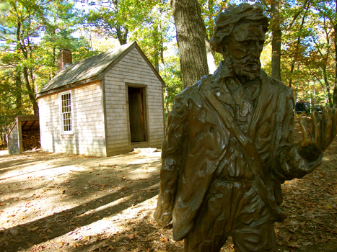
I went into the woods because I wished to live deliberately, to front only the essential facts of life, and see if I could not learn what it had to teach, and not, when I came to die, discover that I had not lived. I did not wish to live what was not life, living is so dear; nor did I wish to practice resignation, unless it was quite necessary. I wanted to live deep and suck out all the marrow life, to live so sturdily and Spartan-like as to put to rout all that was not life, to cut a broad swath and shave close, to drive life into a corner, and reduce it to its lowest terms, and, if it proved to be mean, why then to get the whole and genuine meanness of it, and publish its meanness to the world; or if it were sublime, to know it by experience, and be able to give a true account of it in my next excursion. For most men, it appears to me, are in a strange uncertainty about it, whether it is of the devil or of God, and have somewhat hastily concluded that it is the chief end of man here to “glorify God and enjoy him forever.”
A statue of the famous author now stands by the cabin in which Henry David Thoreau lived in for two years, during his experiment on self-reliance.
“Still we live meanly, like ants; though the fable tells us that we were long ago changed into men; like pygmies we fight with cranes; it is error upon error, and clout upon clout, and our best virtue has for its occasion a superfluous and evitable wretchedness. Our life is frittered away by detail. An honest man has hardly need to count more than his ten fingers, or in extreme cases he may add his ten toes, and lump the rest. Simplicity, simplicity, simplicity! I say, let your affairs be as two or three, and not a hundred or a thousand; instead of a million count half a dozen, and keep your accounts on your thumb-nail. In the midst of this chopping sea of civilized life, such are the clouds and storms and quicksands and thousand-and-one items to be allowed for, that a man has to live, if he would not founder and go to the bottom and not make his port at all, by dead reckoning, and he must be a great calculator indeed who succeeds. Simplify, simplify.
-from Walden (1854), by Henry David Thoreau
As a group, the transcendentalists led the celebration of the American experiment as one of individualism and self-reliance. They took progressive stands on women's rights, abolition, reform, and education. They criticized government, organized religion, laws, social institutions, and creeping industrialization. They created an American "state of mind" in which imagination was better than reason, creativity was better than theory, and action was better than contemplation. And they had faith that all would be well because humans could transcend limits and reach astonishing heights.

