Ch. 2 Population and Health
Key Issue 1 Where Are the World’s People Distributed?
Rubenstein, pp. 46-51

I. INTRODUCTION POPULATION AND HELATH

- What is the Earth’s current population (as of the printing of the book)?

- Most of the world’s population growth is occurring in __________________ countries.

- Describe population growth in

- 2nd-half of 20th Century:

- 21st Century:

- Define overpopulation:

- Is the world currently overpopulated? Explain.

- Define census:

- What are two reasons a census can be controversial? (Explain.)

- Referring to Figure 2-2, the population concentration of the orange area (Africa) and the pink area (part of India, Myanmar, Bangladesh, and Sri Lanka) is _____________________________. Use Figure 2-3 to compare population density of the same two areas:

II. POPULATION CONCENTRATIONS
- The world’s population is highly clustered or concentrated in certain regions. FOUR major population concentrations are identified in the text. SHADE (separate colors) and LABEL the areas of these concentrations on the map. TWO smaller concentrations, or emerging clusters, are also identified. Indicate these on the map as well.

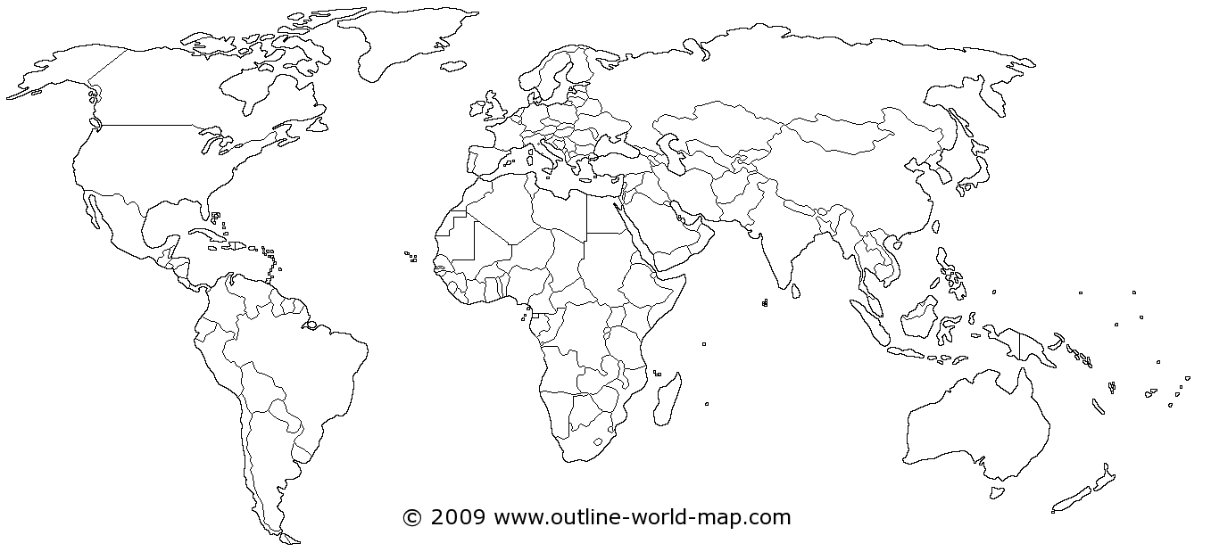

- In the boxes below, make note of significant facts, features, countries involved, and characteristics of the four most important population concentrations and two secondary ones.
EAST ASIA |  | SOUTH ASIA
EUROPE | SOUTHEAST ASIA |  | EASTERN NORTH AMERICA
 |  |  | WEST AFRICA

- Define ecumene:

- What would non-ecumene mean?

- Overtime, what was happened (is continuing to happen) to the percent of the Earth that is ecumene versus non-ecumene?

- List the four “lands” which are sparsely populated on earth in the table below. For each region, briefly explain the reason which makes it inhospitable for human habitation.
Sparsely populated land | Reason for inhospitality

III. POPULATION DENSITY
- Define each of the following terms. Additionally, for each term tell what a high and low number indicate about a population.

- Arithmetic density –

- Physiological density –

- Agricultural density –

