Ch. 3 Migration
Key Issue 2 Where Do People Migrate Within A Country?
Rubenstein, pp. 86-91
I. INTERREGIONAL MIGRATION
- Identify & define the two main types of internal migration:

- Today, the main type of interregional migration is from __________________ to ________________ because…

- Recent immigrants to the U.S. are not distributed evenly across the country, but rather half of immigrants settle in the following 4 states:

- What is the most famous example of large-scale interregional migration in the U.S.?

- A. Define population center:

B. Over the course of U.S. history, the population center has consistently shifted _______________.

C. Where (approximately) is the U.S.’ current population center?

- Identify and take notes on each of the major periods of U.S. interregional migration:

- In recent years, interregional migration has _____________________ because…

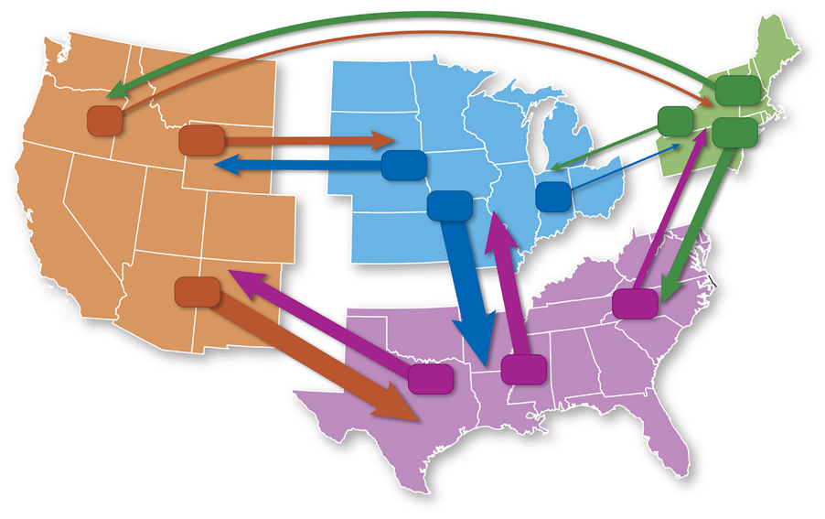

- Use Figure 3-13 on p.85 to calculate the net migration (refer to 3.1 if necessary) of U.S. regions and place the appropriate number in the center of each region on the map. (Do NOT simply copy the numbers from the map onto this one.)

II. INTERREGIONAL MIGRATION IN OTHER LARGE COUNTRIES
- Take general notes on the 4 case studies of interregional migration outside the U.S.:

- Canada -

- Russia -

- China -

- Brazil -

III. INTRAREGIONAL MIGRATION
- Which is more common: intraregional or interregional migration?

- How does intraregional migration differ between developed and developing countries?

- Complete the chart regarding interregional migration.
 | Urbanization |  | Suburbanization |  | Counterurbanization
Definition

Causes

Statistics by Region

