Ch. 4 Folk and Popular Culture
Key Issue 1 Where Are Folk and Popular Leisure Activities Distributed?
Rubenstein, p.112-121

- a. Define culture:

b. Identify and define/give examples of each of the three parts of the definition of culture.

- Similarities and differences between cultures is a largely a result of the ______________________, or lack thereof, of two or more cultures.

- Differentiate between habit, custom, and culture AND give an example of each:

I. INTRODUCING FOLK AND POPOLAR CULTURE
- This is the most important part of the entire chapter! Take detailed notes on the two categories of culture (and differences between them):

a.

b.

- Identify the two main elements of culture:

II. ORIGIN, DIFFUSION, AND DISTRIBUTION OF FOLK AND POPULAR CULTURE
Characteristic | Folk Culture | Popular Culture
Origin

Diffusion – method and speed

Distribution

- Complete the chart below comparing the origin, diffusion, and distribution of folk & popular culture.

- What geographic factors account for the diversity of cultures in the Himalayas?

III. GEOGRAPHIC DIFFERENCES BETWEEN FOLK AND POPULAR CULTURE
- How do the regions covered by folk verses popular culture differ and why do they differ?

- Consider the section describing the connections among musicians. Due to globalization, today connections/interactions don’t have to stem from…

IV. ORIGIN AND DIFFUSION OF FOLK AND POPULAR MUSIC
- Take detailed notes on the origin and characteristics of folk music:

- Take detailed notes on the origin and diffusion of popular music:

- Refer to Figure 4-12. The map illustrates the idea that though popular music (and pop culture in general) is distributed over large areas, there are often _______________________ variations.

V. ORIGIN AND DIFFUSION OF FOLK AND POPULAR SPORTS
13. a. What is the world’s most popular sport?
b. Describe the origin of this sport:

c. How does its origin reflect the origin of elements of folk culture in general?

d. The diffusion of soccer demonstrates that through diffusion, folk customs can become part of
__________________________________.
e. Describe the diffusion of soccer:
f. What is the most widely-viewed event world-wide?

14. Label popular “surviving folk sports” with the countries in which they are the most popular.
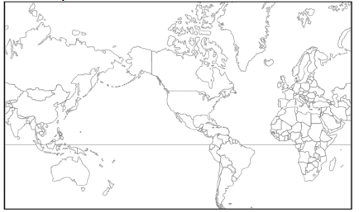
15. How does the diffusion of sports demonstrate both globalization trends and local/regional identity?

