Ch. 5 Languages
Key Issue 3 Why Do Individual Languages Vary Among Places?
Rubenstein, p.164-171

- Dialects are defined as _________________________________________ and are distinguished
by three things:

*Accent =

2. Define subdialect:

3. Why do geographers study dialects and subdialects?

I. ENGLISH DIALECTS

4. In a single word, why is American English different from that spoken in England and elsewhere?

5. Give specific reasons for differences between American and British English in each of the following
areas:
- Vocabulary –

- Spelling –

- Pronunciation –

6. Other than isolationist reasons, why don't Americans speak "proper" English?

7. a. Identify the different English dialects in the U.K.:
b. What is the basis for the different dialects?
c. How are the dialects projected to change and why?

8. a. Define standard language:

b. What is the standard language for of English and where did it come from (3 cities)?

c. How was it diffused throughout Britain?

II. U.S. DIALECTS

9. Explain what an isogloss is.

10. Identify the four major U.S. dialect regions:
11. a. Describe how the differences in origin of the early colonists led to the three different dialects on
the East Coast:

b. Why is there a relatively uniform form of English (dialect) spoken across the enormous area of the western half of the U.S.?

12. Take notes English dialects in U.S. (where? who? differences?):

- African American English -

- Appalachian English -

13. Define creolized language:

III. DIALECT OR LANGUAGE?
14. How have global-local tensions impacted standard languages and dialects?

15. a. Why is it difficult to distinguish individual languages from dialects?

b. What are some examples and where are they spoken?

16. Why do governments promote the designation of a single dialect as the official language?

17. What do the examples of Spanish and Portuguese illustrate?

18. In what two ways do languages vary by gender?

19. Take good notes on the "Gender Differences in Language" section:

IV. MULTILINGUAL PLACES
20. Prepare detailed notes and annotate the maps regarding the following case studies:
Switzerland

*confederation =
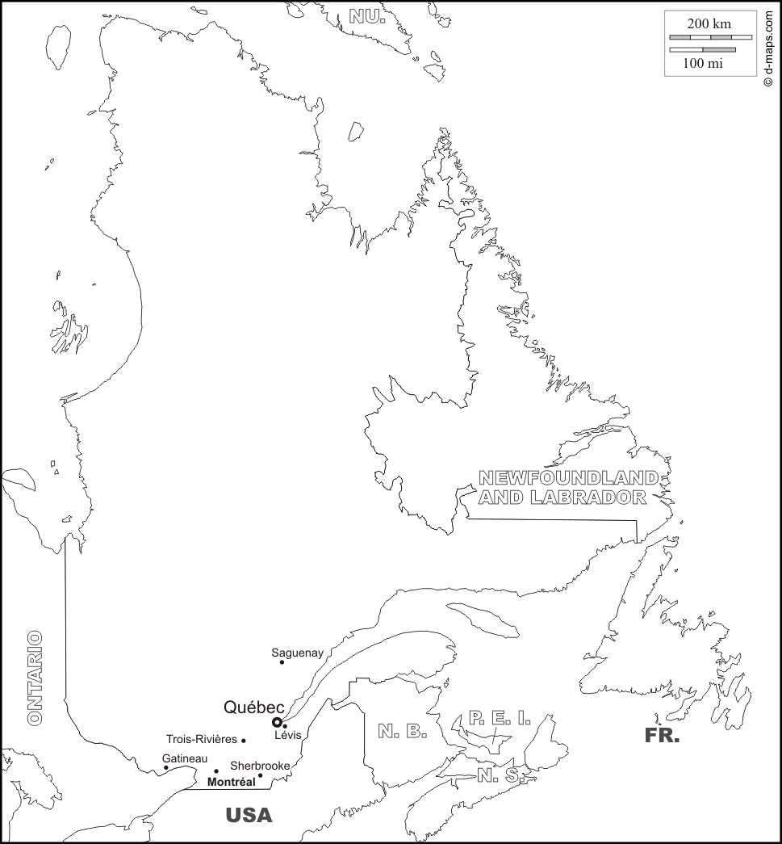
Canada

Nigeria

Belgium

