Ch. 9 Food and Agriculture
Key Issue 1 Where Did Agriculture Originate?
Rubenstein, p.308-311

- Define agriculture:

- Define cultivate:

- Define crop:

I. INTRODUCING FOOD AND AGRICULTURE

- Agricultural Revolution

- Agricultural Hearths - Identify (shade & label) the five agricultural hearths. For each, identify key cultivated crops and domesticated animals along with key dates. Additionally, make a timeline across the bottom and put key developments in chronological order. (Focus on crops/animals mentioned in the reading—you do not have to include everything in Figure 9-2.)
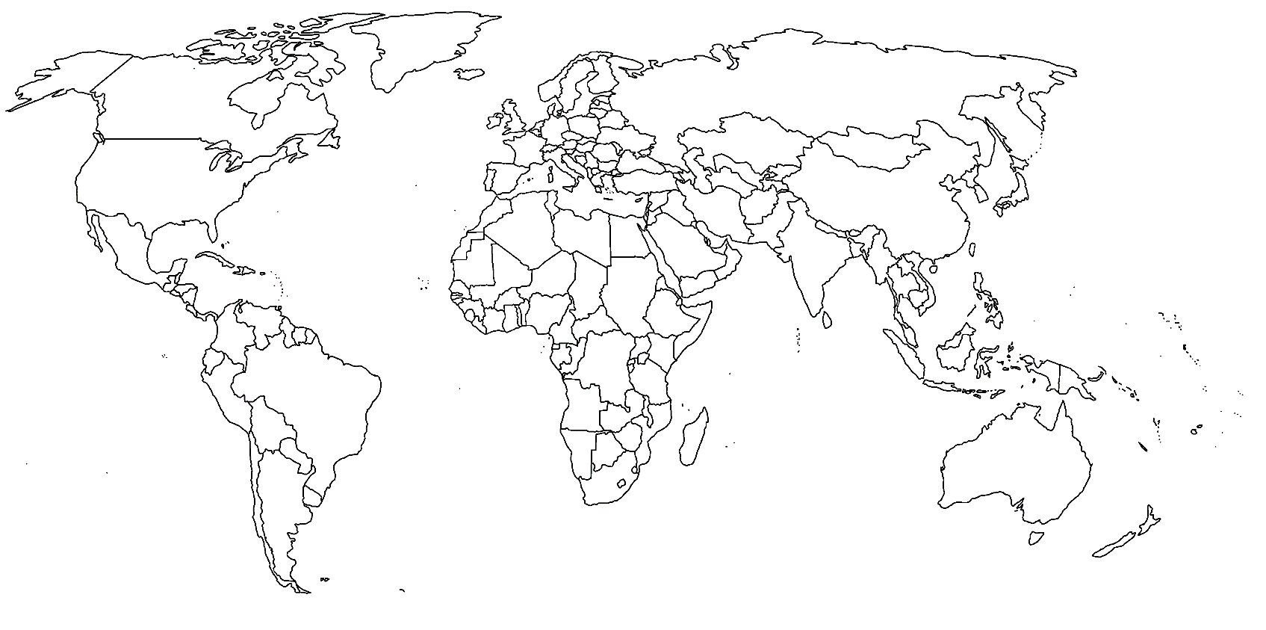

- The fact that agriculture has multiple hearths means that…

II. SUBSISTENCE AND COMMERCIAL AGRICULTURE
*This is key APHG info—make sure to know key differences!
 | SUBSISTENCE AGRICULTURE  (mostly in LDCs) | COMMERCIAL AGRICULTURE  (mostly in MDCs)
Definition/ Purpose of Farming
% of farmers in labor force (and why)
Use of Machinery, Science, & Technology
Farm size
Relationship of farming to other businesses

