Ch. 9 Food and Agriculture
Key Issue 3 Where IS Agriculture Distributed?
Rubenstein, p.316-331

I. AGRICULTURAL REGIONS AND CLIMATE

- a. Geographer _________________________________ (1936) created an agricultural map of the
world that is still widely used today. His map contained 11 agricultural zones:

- 5 are found among developing countries: - 6 are found among developed countries:
pastoral nomadism mixed crop & livestock
shifting cultivation dairy
intensive subsistence, wet rice dominant grain
intensive subsistence, wet rice not dominant livestock ranching
plantation Mediterranean
commercial gardening

c. While there is a correlation between the agricultural map and a world map of ________________

regions, differences in ______________________________ and __________________________

also explain agricultural differences in areas of similar climate. (Viewing climate as the sole

factor in what a region cultivates would be an example of _______________________________,

which most geographers reject.)

- In Figures 9-13 & 9-14, do the agricultural regions match the climate regions more closely in the developed regions developing regions? Why do you think this might be the case?

II. SUBSISTENCE AGRICULTURE IN DEVELOPING COUNTRIES – 5 regions/practices

- What percent of the world’s population today survive by hunting and gathering?

PASTORAL NOMADISM
a. Define pastoral nomadism:

- Found in __________ climates because:

- How do pastoral nomads obtain grain?

- What animals are chosen and why?

- Describe territoriality among pastoral nomads.

- Describe the practice of transhumance.

- Identify reasons pastoral nomadism is declining in practice.
SHIFTING CULTIVATION (also called SLASH-AND-BURN)

a. Found in __________________ climates with (2 characteristics):

b. Identify the two hallmark characteristics of the technique of shifting cultivation.

- What is swidden and how long are they used?

- What is potash?

- In terms of organization, how does the practice of shifting cultivation differ from practices in developed countries?

- How is land owned in a typical village that practices shifting cultivation? Recent changes?

- What percentage of the world’s land area is devoted to shifting cultivation? What percentage of the world’s people work it? What do these figures illustrate about shifting cultivation?

Describe the pros and cons of shifting cultivation.
PROS (Arguments against replacing shifting cultivation) | CONS (How is shifting cultivation being replaced?)

PLANTATION FARMING
- Define plantation farming:

- Found in _____________________ regions, especially in ________________________________,

though often owned by ________________________________________.

- Typical crops:

Define and take notes on intensive subsistence agriculture:

What is double cropping? Examples?

INTENSIVE SUBSISTENCE, WET-RICE DOMINANT
- Define wet rice:

- Where commonly practiced?

- Identify the stages of the time-consuming process shown in the pictures below:
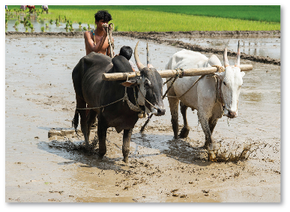

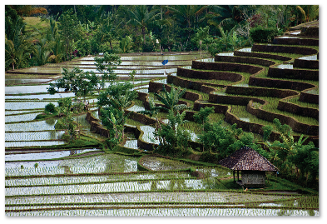

Sawah -

Paddy -
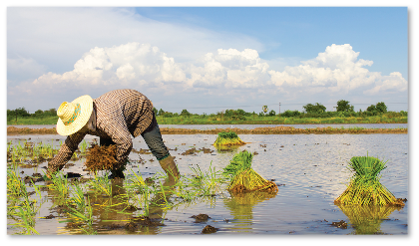

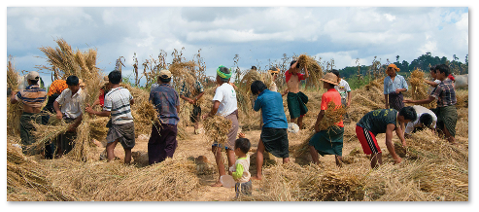

INTENSIVE SUBSISTENCE, WET RICE NOT DOMINANT

- Where practiced and why?

- Common crops:

- Define cash crops:

Examples:

- Define crop rotation:

III. FISHING
- Identify and define the two ways water-based food is acquired:

- Take notes on each of the following practices:

- Fish production -

- Fish consumption -

- Overfishing -

IV. COMMERCIAL FARMING IN DEVELOPED COUNTRIES – 6 regions/practices

Define agribusiness:

- Includes a variety of services/enterprises, such as:

Farmers comprise ________% of the U.S. workforce, but _______% of U.S. laborers work in food production & services related to agribusiness.

(Commercial) GRAIN FARMING

- What is the principal difference between grains common in “commercial grain farming” regions and grains grown in “mixed crop and livestock” regions?

- Identify the three regions of large-scale grain production in North America.

- Identify multiple reasons that show why wheat is an important crop.

- How has the distribution of wheat production changed in the last 50 years?

(Commercial) MEDITERRANEAN AGRICULTURE

- Most crops are grown for:

- Located in what regions? Climate factors?

- Define horticulture:

- Key cash crops along the Mediterranean:

- Key cash crops in California:

COMMERCIAL GARDENING & FRUIT FARMING (also called Truck Farming)

- Located in what regions? Climate factors?

- Types of crops:

- Sold to?

- What is specialty farming? Located?

(Commercial) MIXED CROP & LIVESTOCK

- Describe mixed crop and livestock farming:

- Located in what regions?

- Describe the irony between the amount of land devoted to crops vs. animals and the income generated by each in this region.

- How does this type of agriculture allow farmers to more evenly “distribute their workload”?

- Where is the U.S. Corn Belt and what crop is making rapid inroads among farms there?

- In what different ways is the corn used?

The von Thünen Model (Label the models below.)
(Johann Heinrich von Thünen, 1826)

- Applies to __________________ farming because…

- Key concepts:
  - Describes the relationship between what
two factors/decisions a farmer makes?

  - In making their choices, farmers compare what two costs?

  - Identify/describe each of the model’s rings:

    - First ring:

    - Second ring:

    - Third ring:

    - Fourth ring:

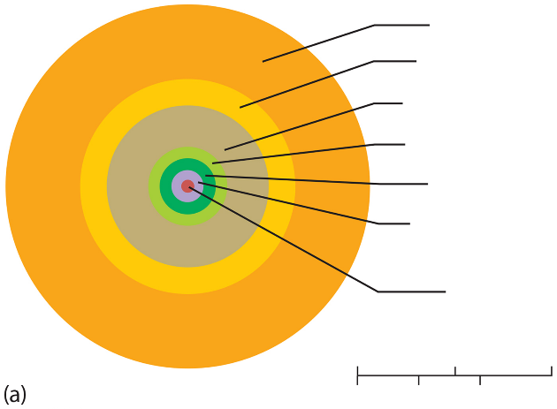

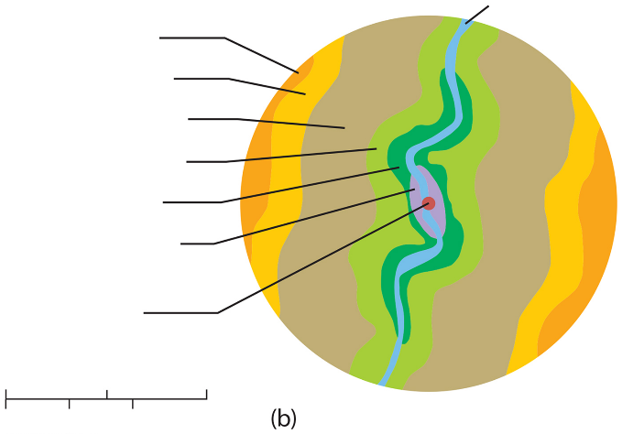

DAIRY

LIVESTOCK RANCHING

(Commercial) DAIRY

- Located where and why?

- Define milkshed:

- Why do some regions specialize in milk products such as cheese and butter rather than fluid milk? Identify some of these important regions.

- What country is the world’s largest per capita producer of dairy products?

Define per capita -

- What challenges do dairy farmers currently face?

(Commercial) LIVESTOCK RANCHING

- Define ranching:

- Located where and why?

- Growth in ranching has occurred where recently? Examples?

- How has ranching changed in the U.S. in recent years? Why?

- What animals are ranched commonly around the world other than cattle?

