A Connell Daily Schedule
8:00-8:30 | Monday | Tuesday | Wednesday | Thursday | Friday
Breakfast and Free Writing | It’s caramel popcorn day! If you could make up your own popcorn flavor, what would it be? | Write a letter to a friend, relative, or teacher you miss. Tell them what you’ve done so far at home | Do you know a real-life superhero? Write about someone who is YOUR hero and why? | Today is National Zoo Lover’s Day!  Do you think animals should be kept in zoos? Why or why not? | Finish this thought: When I become an adult, the first thing I want to do is…
Week 4 Journal Writing: This week respond to the prompts or create a prompt of your own. Have your child find a quiet spot and have them write for 20 to 30 minutes. Don’t worry about grammar or spelling as this activity is intended for providing reasons to support their choices over conventions of writing. The most important part is that your child answers the question. Adaptation: If your child struggles writing, have your child orally answer your question. Make sure they stay on topic and give reasons that fit the topic.

8:30-9:30 | Monday | Tuesday | Wednesday | Thursday | Friday
Online Amplify | Amplify | Amplify | Amplify | Amplify | Amplify
Week 4 Continue Amplify: This online reading program is tailored for your child’s individual needs. The system will adjust up and down based on your child’s responses to questions. The more you use the system the more it pinpoints your child’s needs. Please note that there are educational games based on your child’s progress. Please monitor your child to make sure they don’t always end up on the games.

9:30-10:00 | Monday | Tuesday | Wednesday | Thursday | Friday
PE/Physical Exercise  Healthy Snack | https://www.youtube.com/watch?v=R-BS87NTV5I  “Harry Potter Yoga” | https://www.youtube.com/watch?v=coC0eUSm-pc  “Star Wars” Yoga  Enjoy the weather and take a walk in your backyard or around the block with you parents! | https://www.youtube.com/watch?v=9xng62RWa_k  “Moose on the Loose”  Indoor Recess | https://www.youtube.com/watch?v=U9Q6FKF12Qs  “Trolls Yoga” | https://www.youtube.com/watch?v=QfR-XqcMjGo  “Hang in There”  “
Week 4 This week we are introducing mindfulness and relaxation using Cosmic Kids Yoga as we continue with some indoor recess via GoNoodle! If you’re able to, try to get out in your back yard and enjoy some fresh air or go for a nice walk with your family.

10:00-10:30 | Monday | Tuesday | Wednesday | Thursday | Friday
Social Studies  Geography | https://www.youtube.com/watch?v=YrT5jcnu8NA  “Continents of the World”  What is the name of our continent? Which type of biome do we live in? | https://www.youtube.com/watch?v=X3uT89xoKuc  “Destination World: Antarctica”  National Geographic  Before you begin, what do you already know about Antarctica? After watching, share something new you learned! | https://www.youtube.com/watch?v=q-up6zuCQQg  “Oceans of the World  What makes an ocean different from a river or a lake? | https://www.youtube.com/watch?v=PSYHMWmyVfo  “Destination World: Africa”  Name the two seasons of the Savannah.  If we only had two seasons, which ones would you want? Why? | https://www.youtube.com/watch?v=FGPFzHw-NDo  Mystery Doug: “Why are oceans salty?”  In your own words, tell someone the answer!
Week 4: This week, we are introducing some Social Studies concepts using National Geographic, Mystery Doug, and Homeschool Pop. Homeschool Pop has a number of grade-level specific videos that are actually beneficial for all grades K through 5.

10:30-11:00 | Monday | Tuesday | Wednesday | Thursday | Friday
Related  Arts Activities | Art  Selfie Time  Make a self-portrait using crayons, markers, pencils, rice, or macaroni noodles! | Library  Find a quiet spot in your house and read a book you have at home or have someone read to you.  What was your favorite part of today’s story? | Music  Make an instrument out of recycled materials.  Put on a family concert by playing along to your favorite song. | Field Trip  Take a tour of the Secret Annex to learn about Anne Frank and her family at  https://www.annefrank.org/en/anne-frank/secret-annex/ | STEM- The Leakproof Bag  Using a plastic baggie and sharpened pencils, complete this stem challenge!  https://www.stevespanglerscience.com/lab/experiments/leak-proof-bag/
Week 4: This week we are taking a trip to Anne Frank’s Secret Annex in Amsterdam. Do a little research to learn about who Anne Frank was and why her story is so important.

11:00-12:00 | Monday | Tuesday | Wednesday | Thursday | Friday
Lunch | Change it up for lunch today!  Try something new | Connell Kids love breakfast for lunch days!  Have some pancakes or waffles for lunch! | Taste the Rainbow!  Add some color to your lunch by trying to eat red, yellow, and purple fruits and veggies with lunch today | Pizza Day!  Get creative! Build something that looks like a pizza for lunch using different food items. | Reduce the amount of sugary drinks you consume and add some water with lunch instead.
Lunches are still served Monday, Wednesdays, and Fridays at any Erie Public school from 10:00-1:00. Students are given lunch and breakfast for the next day!

12:00-1:00 | Monday | Tuesday | Wednesday | Thursday | Friday
I-Ready online  Math Program | i-Ready | i-Ready | i-Ready | i-Ready | i-Ready
This online Math program is tailored for your child’s individual needs. The system will adjust up and down based on your child’s responses to questions. The more you use the system the more it pinpoints your child’s needs. Please note that there are educational games based on your child’s progress. Please monitor your child to make sure they don’t always end up on the games.

1:00-1:30 | Monday | Tuesday | Wednesday | Thursday | Friday
Scholastic at Home | Scholastic at Home | Scholastic at Home | Scholastic at Home | Scholastic at Home | Scholastic at Home
Scholastic offers amazing daily and weekly activities on Scholastic Learn at Home for each grade level band! Check it out by visiting: https://classroommagazines.scholastic.com/support/learnathome.html

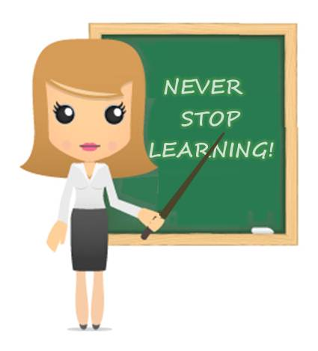
MARK YOUR CALENDER FOR APRIL 20TH – THE START OF GOOGLE CLASSROOM!

