Operations with Fractions

Changing Mixed Numbers to Improper Fractions

- Multiply the denominator times the whole number
- Add the numerator
- Keep the denominator the same

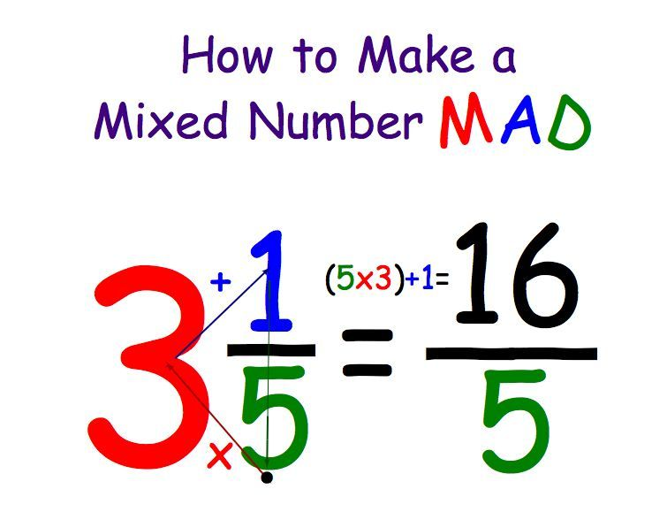

Adding Fractions

- Change any whole or mixed numbers to improper fractions
- Find common denominators
- Add the numerators
- Keep the denominators the same
- Simplify

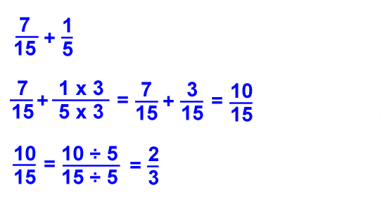

Subtracting Fractions

- Change any whole or mixed numbers to improper fractions
- Find common denominators
- Subtract the numerators
- Keep the denominators the same
- Simplify

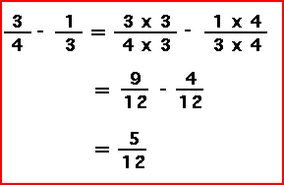

Multiplying Fractions

- Change any whole or mixed numbers to improper fractions
- Multiply the numerators
- Multiply the denominators
- Simplify

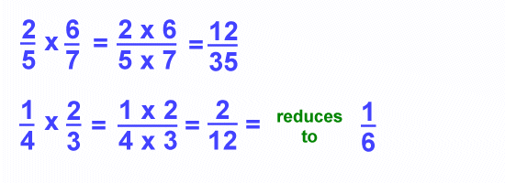

Dividing Fractions

- Change any whole or mixed numbers to improper fractions
- Keep the first number the same
- Change to multiplication
- Flip the second fraction
- Multiply the numerators
- Multiply the denominators
- Simplify

