Tricky Words List 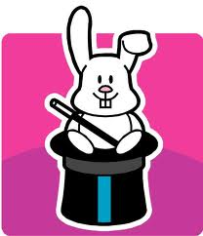

a some once says here
I from to was because
no word do when there
so are two where could
of were who why would
is have the what should
all one said which their
be they by my down
he you today yesterday tomorrow
me your Sunday Monday Tuesday
we Wednesday Thursday Friday Saturday
she how picture

**Remember the red letters are the letters you must stop and think about the tricky sounds that are being made!**

Word Chains
Directions: Read first word in chain out loud and have student write it. Then ask student to change one of the letters to make the second word. Repeat this again until the student has spelled all words in the chain. (I sometimes will give them clues such as change one letter in pat to make a word that is an animal that meows - cat.)

1. dot > pot > pat > cat > cap > cop > cod > pod > pad > dad
2. pot > pod > cod > cop > cot > cat > cap > tap > top > pop
3. pin > pig > dig > dog > dot > not > got > pot > pit > pat
4. dip > tip > tap > nap > nag > gag > tag > tan > pan > can
5. mad > man > van > pan > pin > tin > fin > fan
6. vat > mat > map > tap > tip > tin > tint > mint
7. mop > map > gap > cap > camp > damp > dam > dim
8. sip > hip > hop > hog > fog > fig > fin > fit > sit > sat
9. sad > sand > hand > had > hat > hot > hit > pit > spit > spin
10. hip > sip > zip > zips > zaps > zap > tap > tat > pat > pot

