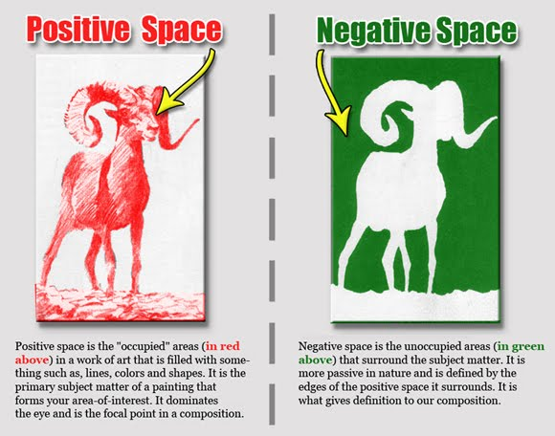
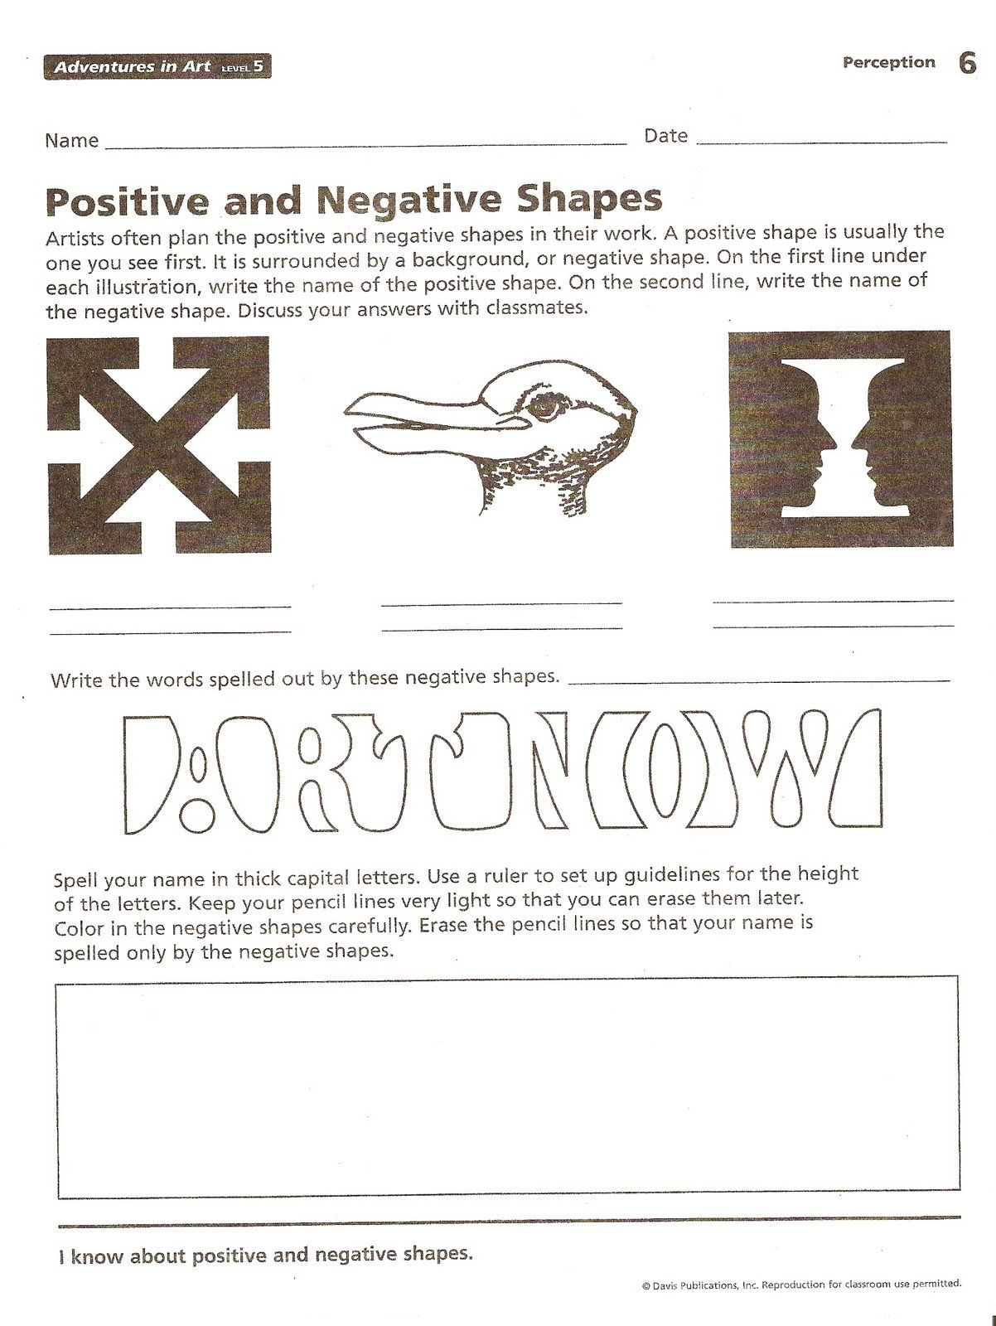
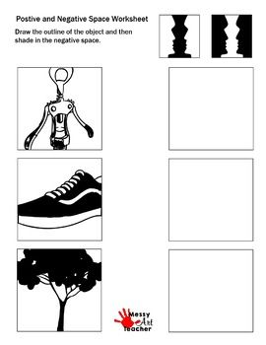
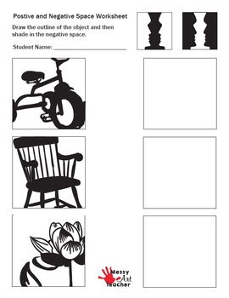
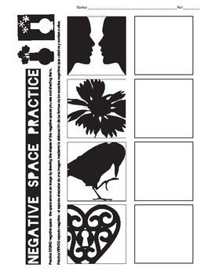

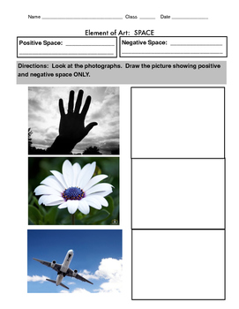

Name Class/Day
Glass Etching Inspiration
Requirements:
- Uses positive/negative space.
  - Where the sticker is, is where it will be clear.
  - Where the sticker is not, is where it will be frosted.
- Variety of line thicknesses (thick to thin).
- Your own design.
  - No copywritten images such as logos, sports teams, popular characters, emojis, etc.
  - Can be a famous person, but your own simplification of it.
- Detailed
  - It should not be just a super simple thing like a basic tree.
  - Can have inner designs inside a simple silhouette.

Theme: Select your theme from this list: (1 pt)

- Names/words
- Animals
- Places
- Objects
- Plants
- Portrait

Word Association: List at least 10 words that relate to your chosen theme. If you a choosing a word, it must be 5 or more letters. (5 pts)

1.
2.
3.
4.
5.
6.
7.
8.
9.
10.

Sketch three (3) positive/negative designs for your project that is based on your brainstorm. Once you have chosen a design, place a star in the box. Take your time drawing your designs! (5 points for each completed idea box)
Idea 1

Color(s):

Idea 2

Color(s):

Idea 3

Color(s):

Packet Total /50

