11-1 Opener - Area of Quadrilaterals
Name: _________________________________ Date:________ Period:________
- Find the area of the given figures.
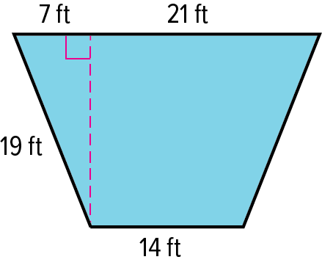
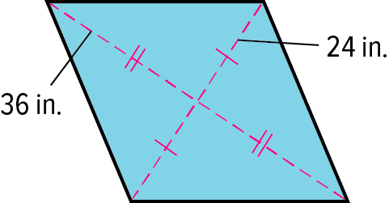

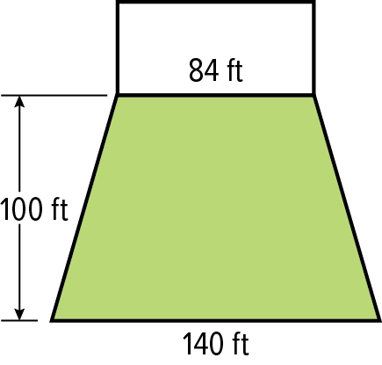
2) GRASS SOD A landscaping contractor is installing grass sod on the lawn of a new office building.
a. What is the area of the lawn?

b. If the cost of the sod is $1.10 per square foot, what is the price for the new lawn?

- If the area of a parallelogram is 676 miles and the height is four times the length of the base, what are the lengths of the base and height?

11-1 Exit Slip - Area of Quadrilaterals
Name: _________________________________ Date:________ Period:________
- Find the area of the given figures.
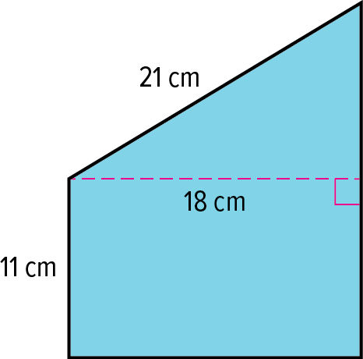
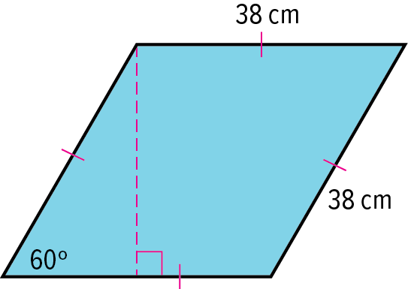

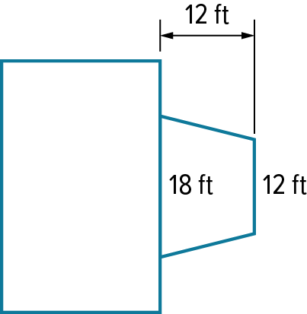
2) CONCRETE PATIO The Campbells are planning on having a concrete patio in the shape of a trapezoid installed at their back door.
a. What is the area of the patio?

b. If the price to install the concrete patio is $7.20 per square foot, what should the Campbell’s budget be for the project?

3) If the area of a kite is 44 square inches and the length of the long diagonal is 11 inches, what is the length of the short diagonal?

11-2 Opener – Area of Regular Polygons
Name: _________________________________ Date:________ Period:________
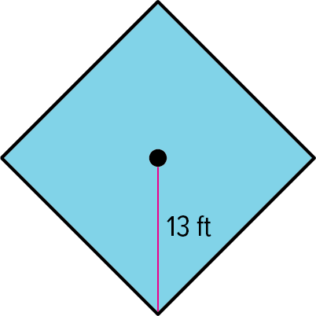
- Find the area of the polygons.
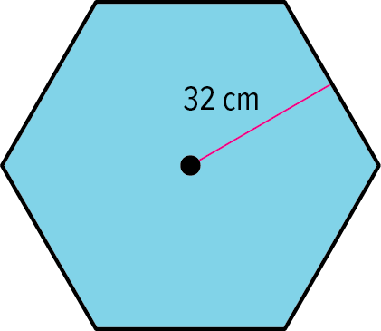

- In each figure, a regular polygon is inscribed in a circle. Identify the center, a radius, an apothem, and a central angle of each polygon. Then find the measure of a central angle.
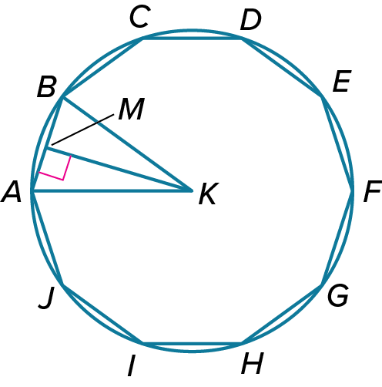
.

- Find the area of the figure. Round to the nearest tenth, if necessary.
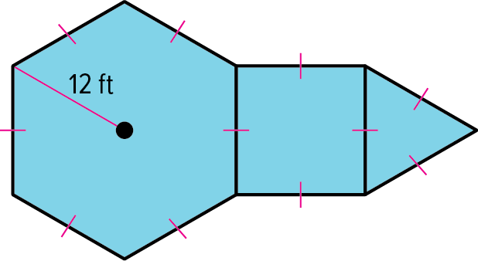
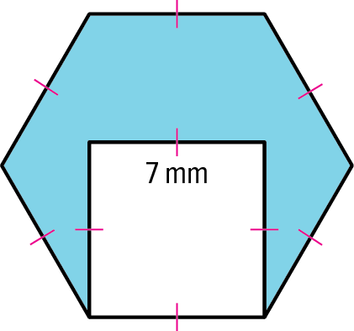

11-2 Exit Slip – Area of Regular Polygons
Name: _________________________________ Date:________ Period:________
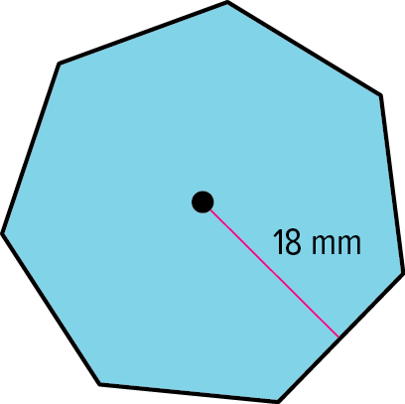
- Find the area of the polygons.
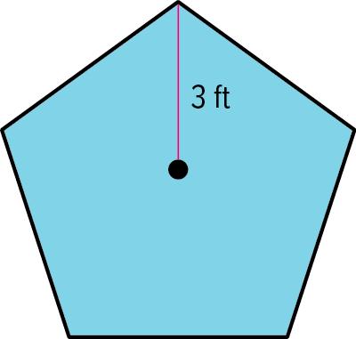

- In each figure, a regular polygon is inscribed in a circle. Identify the center, a radius, an apothem, and a central angle of each polygon. Then find the measure of a central angle.
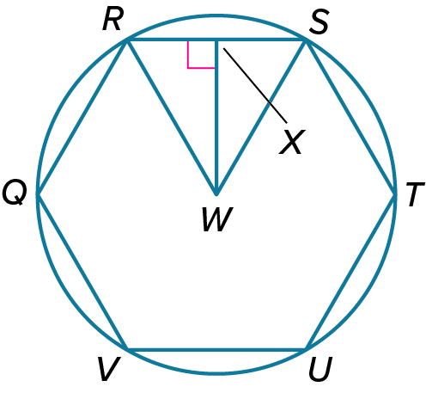
.

- Find the area of the figure. Round to the nearest tenth, if necessary.

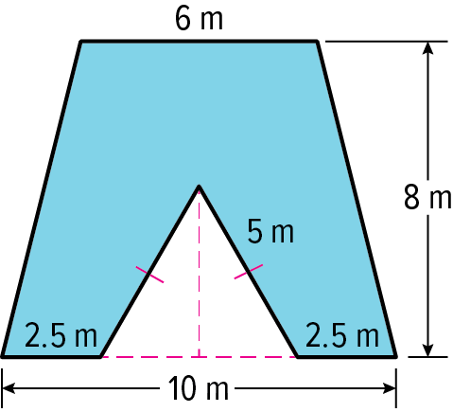
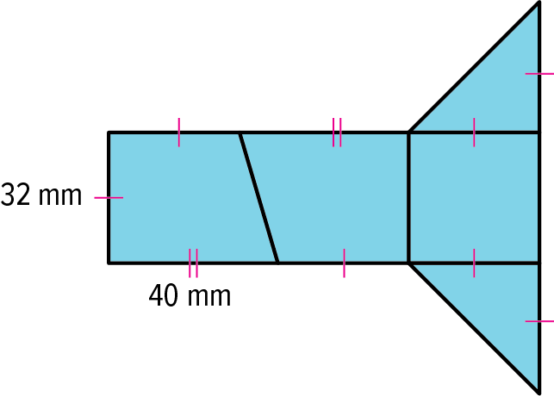

11-4 Opener – Surface Area
Name: _________________________________ Date:________ Period:________
- Find the lateral area and surface area of each solid.
Round to the nearest tenth, if necessary.
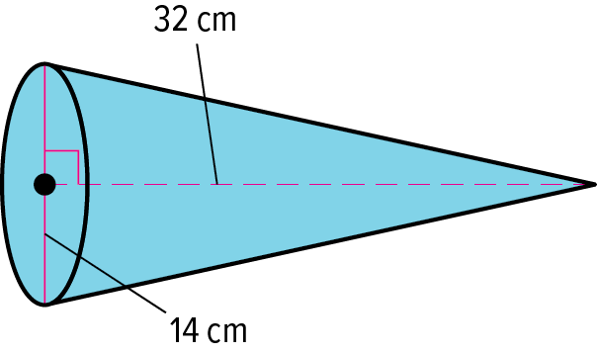
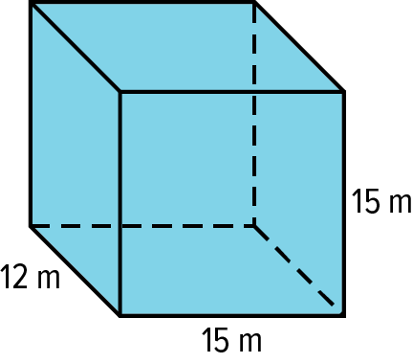
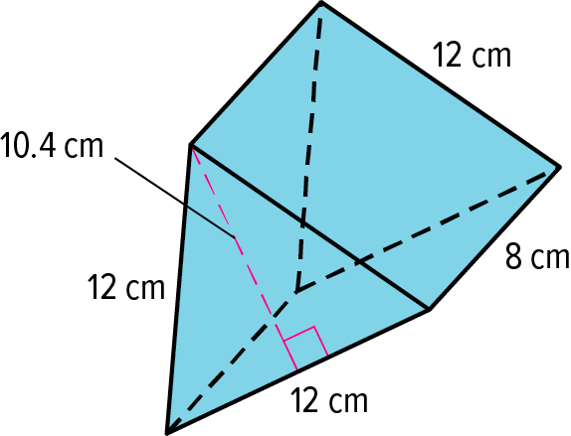

- Find the surface area of the solids. Round to the nearest tenth, if necessary.
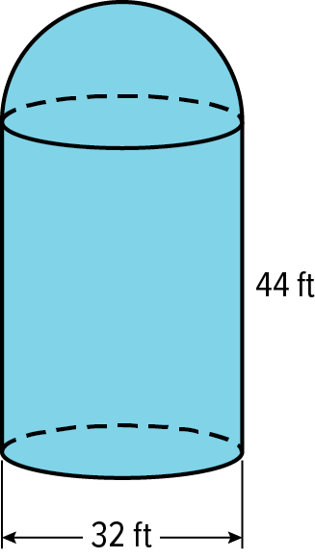
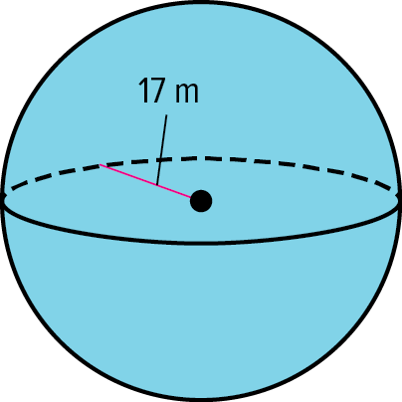

11-4 Exit Slip – Surface Area
Name: _________________________________ Date:________ Period:________
- Find the lateral area and surface area of each solid.
Round to the nearest tenth, if necessary.
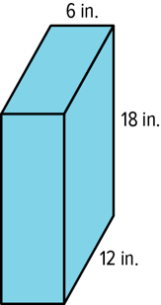
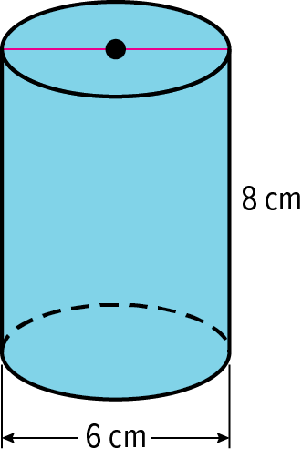
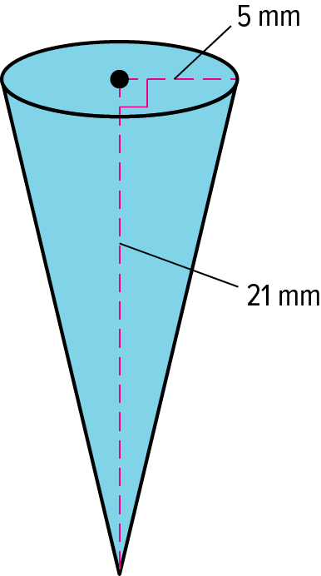

- Find the surface area of the solids. Round to the nearest tenth, if necessary.
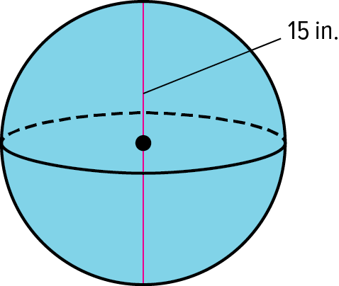
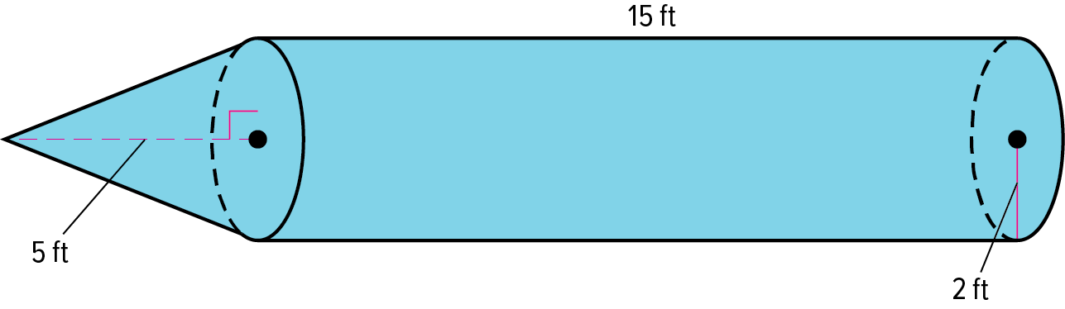

11-6 Opener – Volume of Prisms and Pyramids
Name: _________________________________ Date:________ Period:________
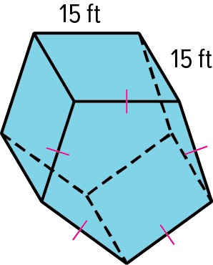
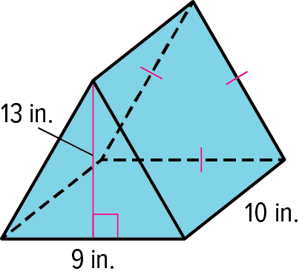
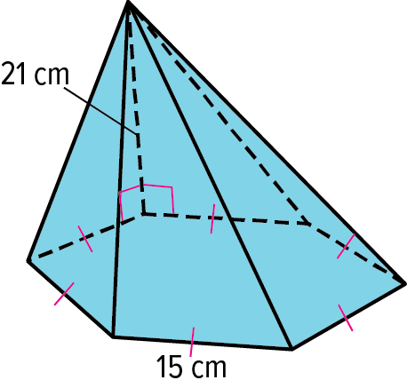
- Find the volume of each prism or pyramid. Round your answer to nearest tenth, if necessary.

BLOCK OF CHEESE A chef is purchasing cheese for a dish and wants to calculate the volume of cheese in a single block.
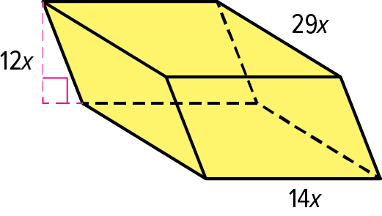
a. Find the volume of cheese in terms of x.

b. Find the volume of cheese if x = 5 mm..

11-6 Exit Slip – Volume of Prisms and Pyramids
Name: _________________________________ Date:________ Period:________
- Find the volume of each prism or pyramid. Round your answer to nearest tenth, if necessary.
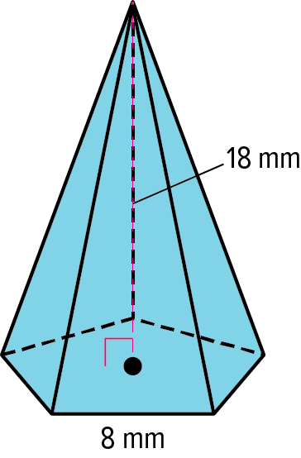
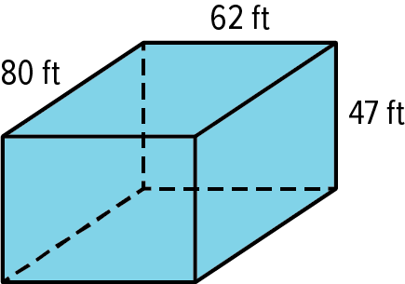
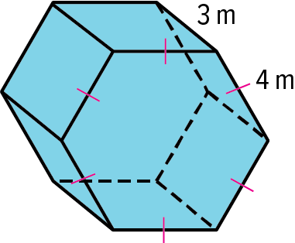

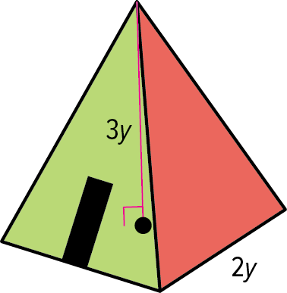
PYRAMID CONSTRUCTION A wilderness survival expert is constructing a pyramid-style structure to house guests for retreats and workshops. The structure will be in the shape of a regular square pyramid with side lengths of 2y and a height of 3y.
a. Find the volume of the structure in terms of y.

b. Find the volume of the structure if y = 5 feet.

11-7 Opener – Volumes of Cylinders, Cones, and Spheres
Name: _________________________________ Date:________ Period:________
- Find the volume of a cylinder with a radius of 2x + 3 inches and a height of 4x inches.

a. Find the volume of the cylinder in terms of x and $π$ .

b. Find the volume of the cylinder if x = 3 inches. Round your answer to the nearest tenth.

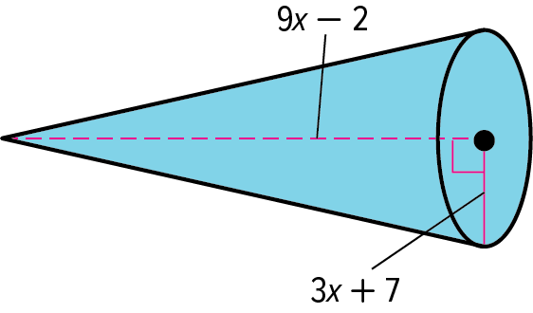
- Examine the cone. Round your answer to the nearest tenth, if necessary.
a. Find the volume of the cone in terms of x and $π$.

b. Find the volume of the cone if x = 12 millimeters.

- Examine the sphere. Round your answer to the nearest tenth, if necessary.
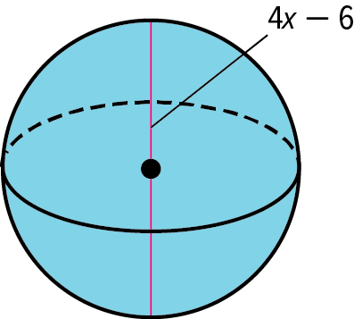
a. Find the volume of the sphere in terms of x and $π$.

b. Find the volume of the sphere if x = 5 centimeters..

11-7 Exit Slip – Volumes of Cylinders, Cones, and Spheres
Name: _________________________________ Date:________ Period:________
- Find the volume of a cylinder with a diameter of 16x inches and a height of 12x – 3 inches.

- Find the volume of the cylinder in terms of x and $π$ .

b. Find the volume of the cylinder if x = 2 inches. Round your answer to the nearest tenth.

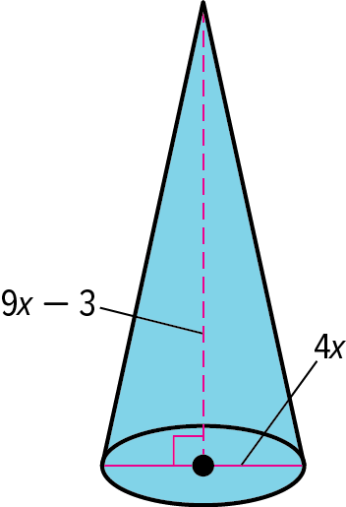
- Examine the cone. Round your answer to the nearest tenth, if necessary.
a. Find the volume of the cone in terms of x and $π$.
b. Find the volume of the cone if x = 7 meters.

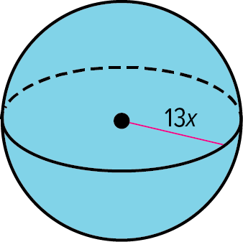
- Examine the sphere. Round your answer to the nearest tenth, if necessary.
a. Find the volume of the sphere in terms of x and $π$.

b. Find the volume of the sphere if x = 3 centimeters.

