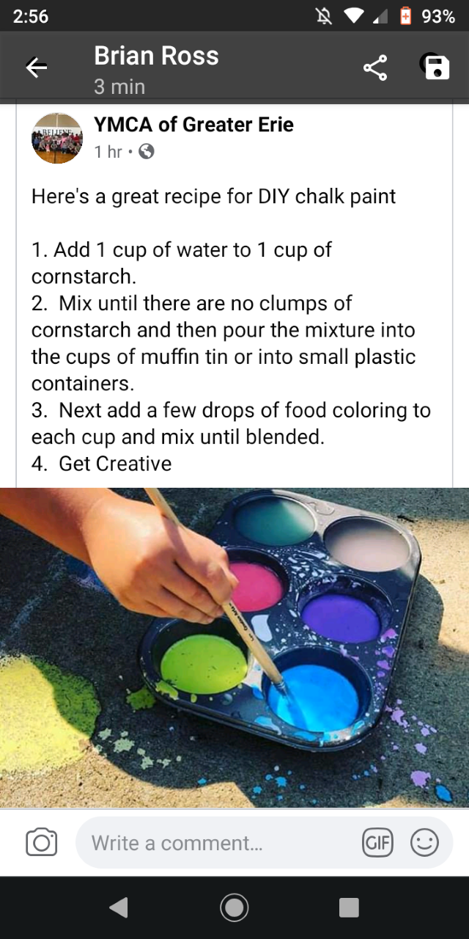

**A little something fun to try out when the weather starts to warm up!!**