LESSON 8: Proportional Relationships & Slope
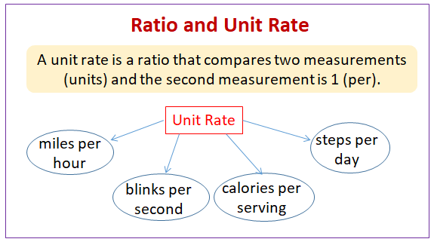
SLOPE=UNIT RATE

For a table to be proportional it must:
1) make a straight line
2) move through origin (0,0)
If it does not make a straight line and move through the origin, it is NOT PROPORTIONAL.

Dependent vs. Independent Variables
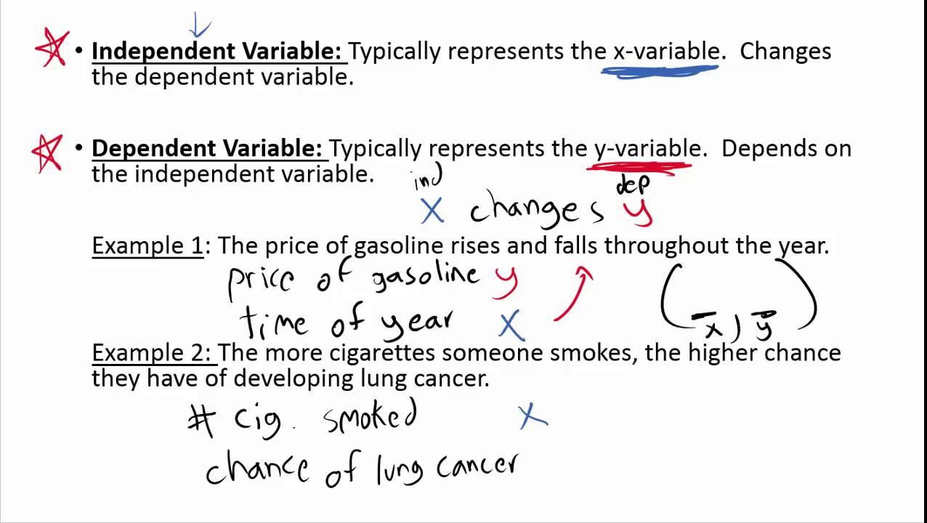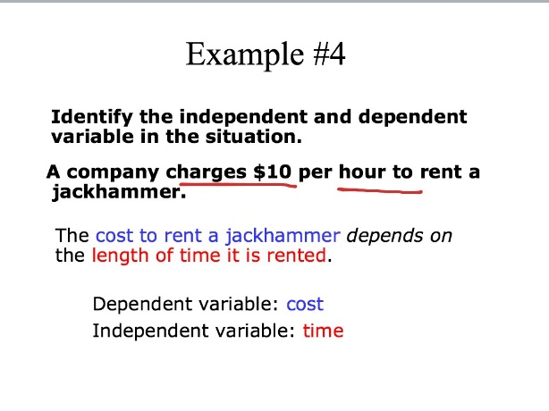

FINDING SLOPE:
1. -Place dots in every corner of boxes that the line passes through
-Divide: y/x
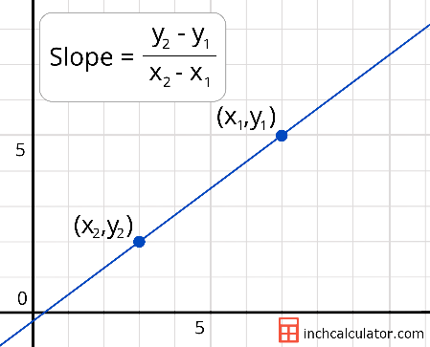

2. RISE
_________
RUN

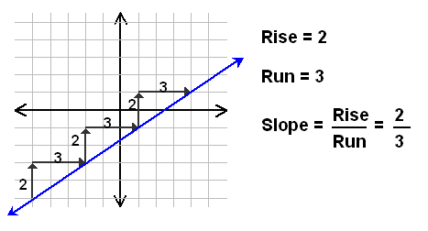

3. y-y
----------- (slope formula)
x-x
