Lettering Packet

This packet is designed to give you better designs for lettering and work on your lettering styles and stamina for drawing. Try your best in this packet! Use pencil or pen.

This packet is due by end of class on Friday, March 6th and is 50 points!

Name Block

- In the space below: Draw your name as creatively as you can. (5 pt)

9 square
- Select one letter or number. Draw the same letter or number, 9 different ways. (10 pts)

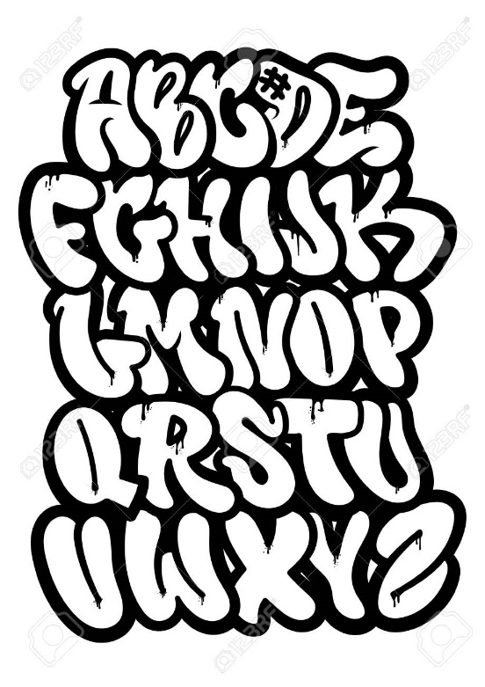
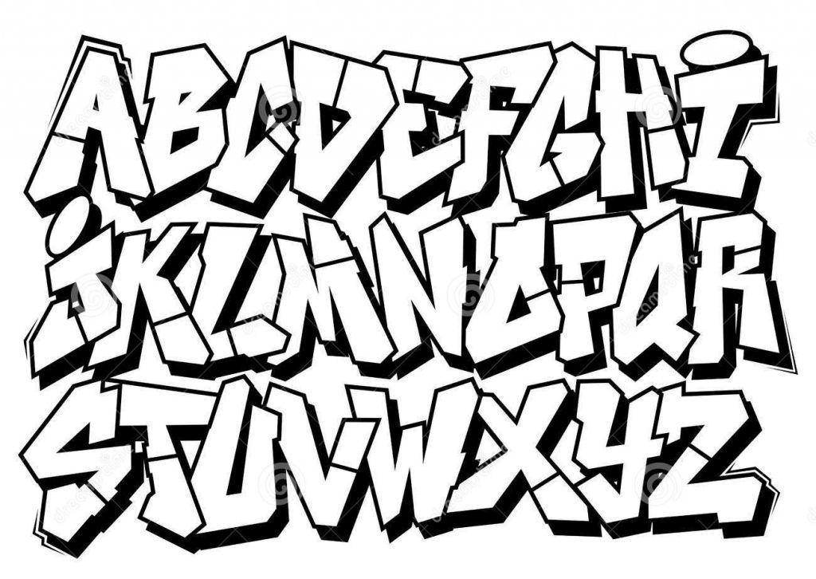

- Using one of above fonts: Write your nickname or your name. (example: J-Dubbs, Won-dawg, etc.) (5 pts)

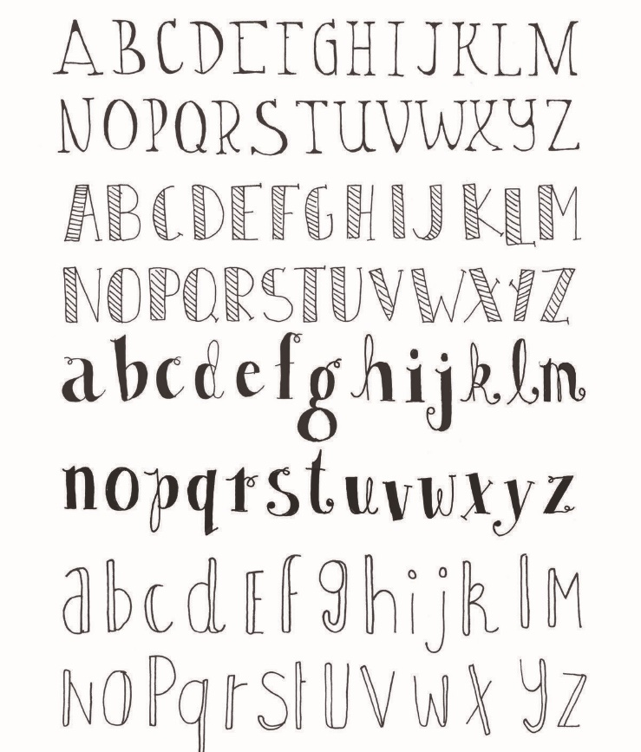
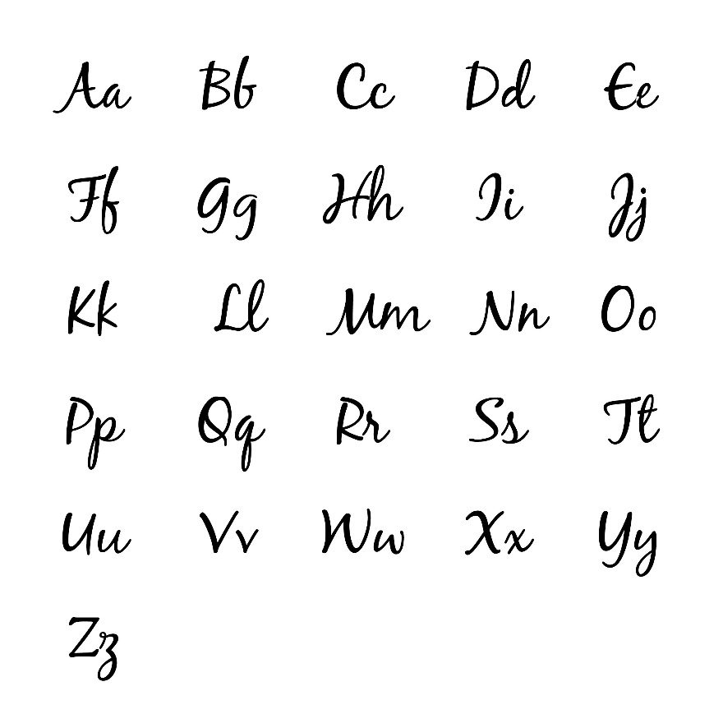

- Using one of the above fonts: Write an inspirational word to you. (example: create, hope, love, unique, faith, laugh) (5 pts)

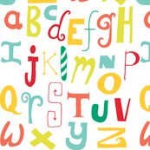

- Using one of the above fonts: write a playful word (example: play, bounce, pretend, imagine, etc.) (5 pts)

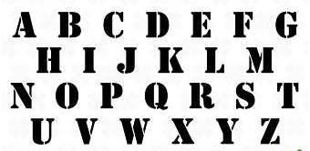

- Using one of the above fonts: write a powerful word. (examples: power, courage, brave, strong, etc.) (5 pts)

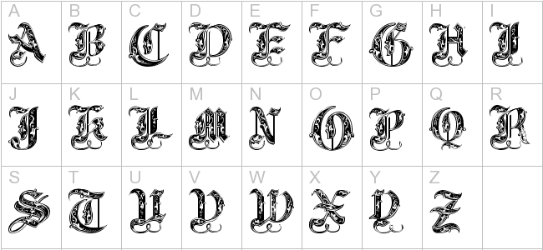

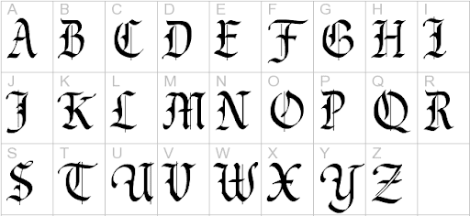

- Using one of the above fonts: write a fancy word. (examples: couture, rich, royal, etc.) (5 pts)

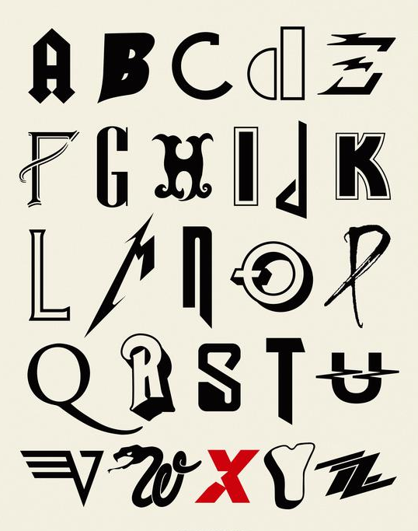
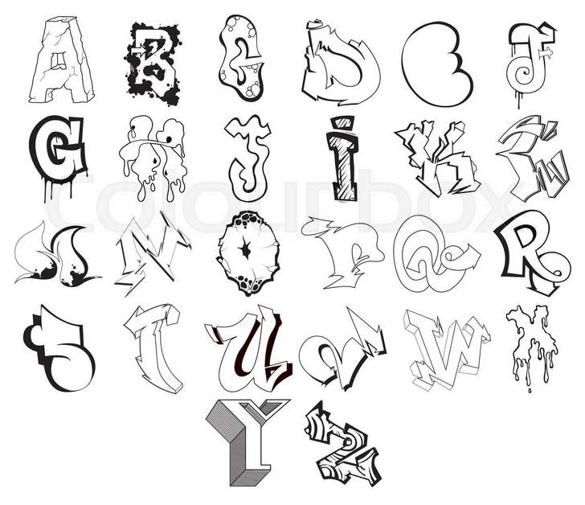

- Using one of the above fonts: write a band or singer’s name. (example: BTS, Metallica, Kei$ha, Kodak Black, etc.) (5 pts)

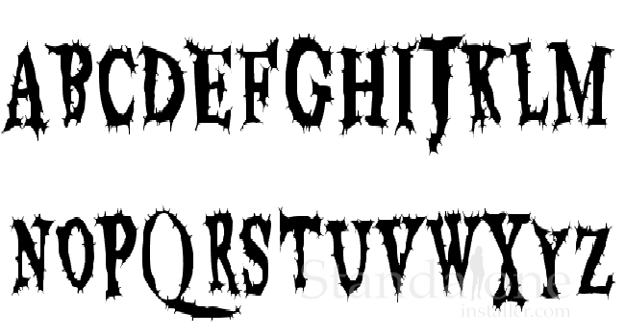

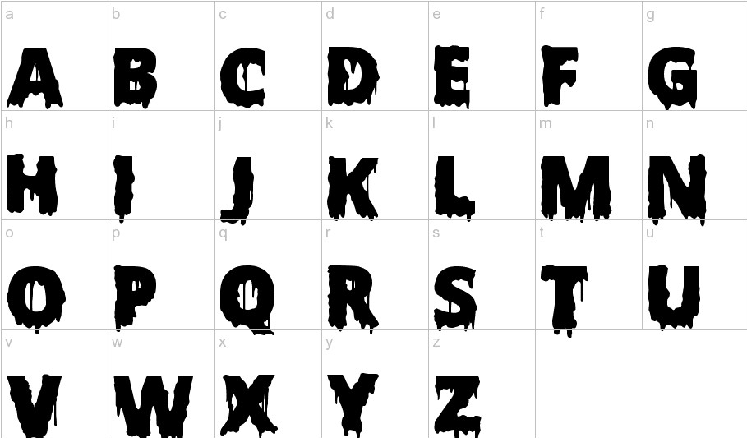

- Using one of the above fonts, write a scary word. (examples: creepy, spooky, haunting, alien, etc.) (5 pts)

Total Packet points /50

