Name: ___________________________________________________________________Grade: ___________________

Photo Digital Test

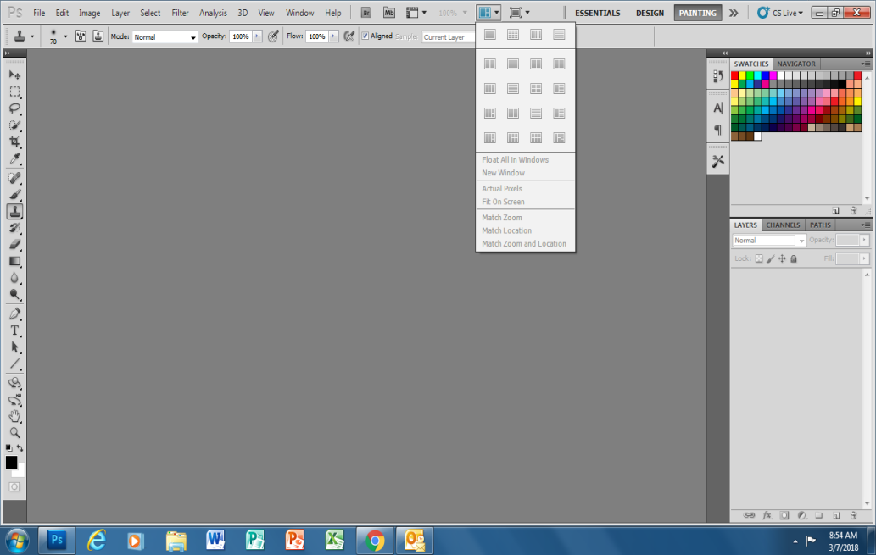

What does this tool do? Please explain in detail Write your answer in the box to the right

- What does the Magic Eraser Tool specifically do? Please explain in detail

- You can have multiple projects/pictures open at one time? True / False

- What does “CTRL T” do on your keyboard? List all functions.

- Why is it important to Name your LAYERS in the layers panel? Explain in detail

- What are a few ways to “select an Image” in Photoshop? (Hint, you need a minimum of two ways)

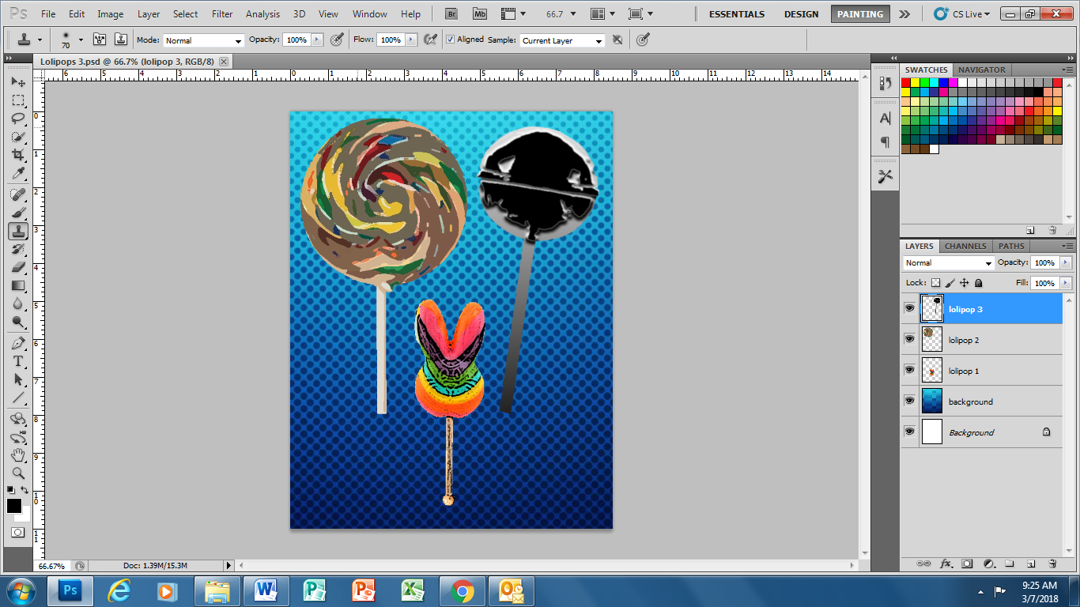

How do you move layers around in the layer panel? Please explain in detail in the box on the left.

- Explain how you insert “TEXT” into your project. Please list the steps.

- You are able to create a project with whatever width and height you want? True / False?

- What is a gradient?

- What does CTRL A, CTRL C and CTRL V do? Explain all 3.
CTRL A –
CTRL C-
CTRL V-

- 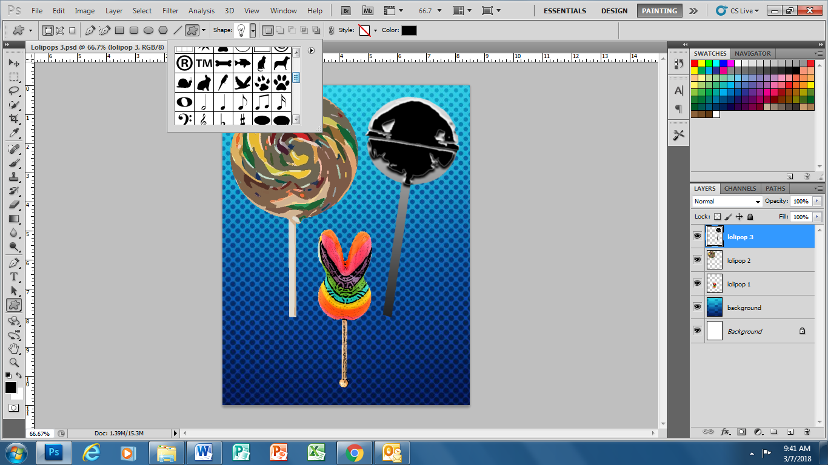

What does this tool do? Explain in the box to the right
- Why is it a good idea to “Flatten” your project when you are all finished?

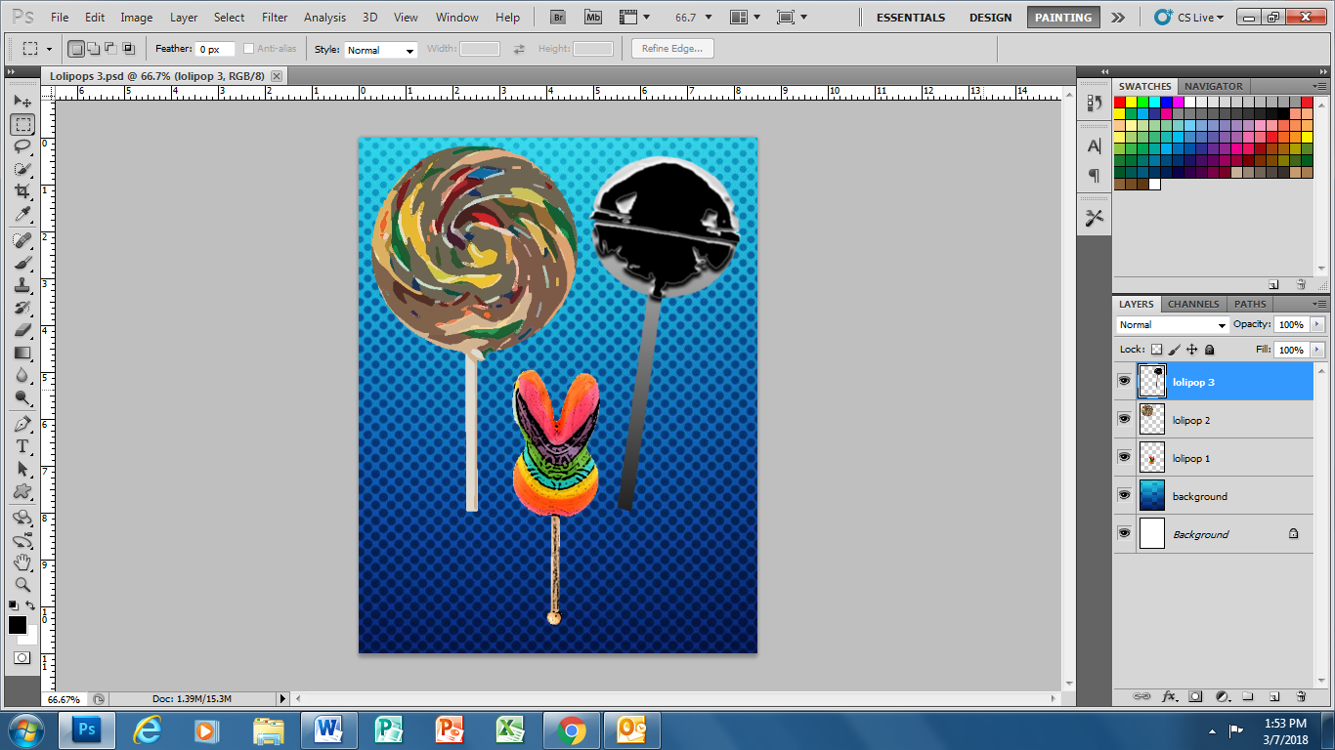

What do these icons do? Explain in detail in the text box on the right

- What are the 3 file extensions most commonly used when searching for Images.

