Angles-Lesson 21 Quiz Notes
Congruent- EQUAL
Transversal- a 3rd line that cuts or crosses 2 lines

Vertical angles- each of the pairs of opposite angles made by two intersecting lines.
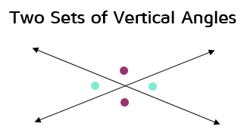

Corresponding angles- angles in the same position in the intersections of the transversal and each of the parallel lines
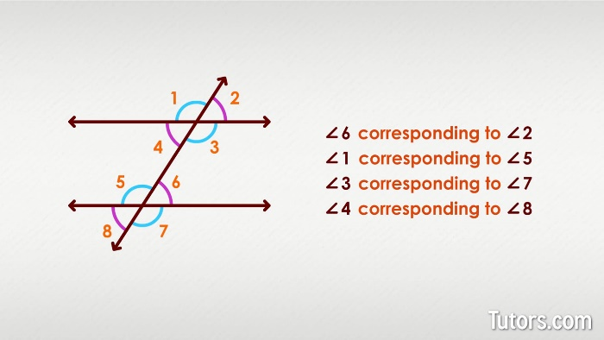

Alternate Interior angles- inside (between) the two parallel lines and they are on alternate (opposite) sides of the transversal.
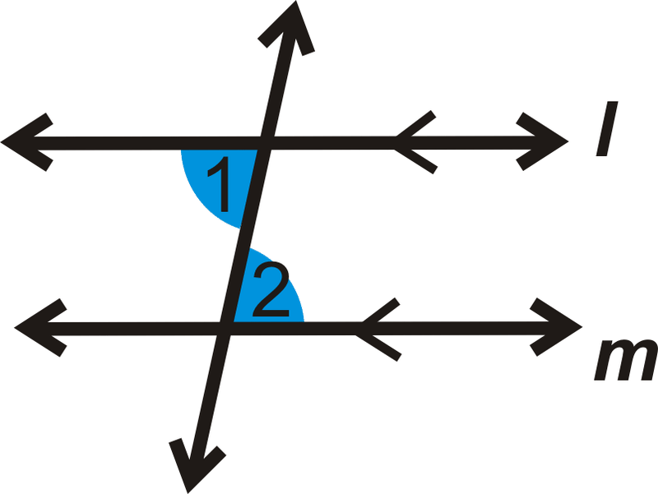
Adjacent angles (linear pair)- two angles that have a common vertex and a common side but do not overlap (next to each other)
-will not have the same measurement
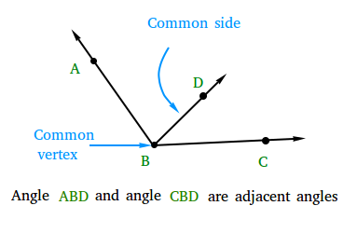

Same Side Interior Angles- angles on the same side of the transversal that crosses parallel lines
